Abstract if ai content detect :

Blind spot refers to the areas around a vehicle .These areas cannot be seen by the driver ,the driver cannot see them while looking either forward or through side or rear view mirror., which leads to numerous annual traffic accidents. In the past few years, new blind spot warning systems for vehicles have come on the market. These work on radar for the most part, which is effective but limited due to analog signals in detecting a wide variety of objects.
This more sophisticated system uses deep learning in combination with cameras to provide the user's live blind spot views. Cameras may achieve much better quality, meaning that images will be more accurate and will allow detection to be performed much better. Our system generates timely warnings for the driver by embedding deep learning algorithms, such as predicting vehicle movement with the help of recurrent neural networks or accident probability estimation with the help of Hidden Markov Models. In addition to these, histogram extraction techniques along with SIFT (Scale-Invariant Feature Transform) for the purpose of enhancement of object detection capability are also available.
Our solution is far better than radar-based systems as it gives greater precision and clarity of visualization and the responsiveness for real-time is much better for drivers, providing a much more comprehensive system for proactive monitoring of blind spots that will really improve road safety.
CHAPTER 1: Introduction
1.1 GENERAL INTRODUCTION
1.2 SPECIFIC INTRODUCTION
1.3 Contribution
1.4 Problem Analysis
1.5 Purpose of This Work

CHAPTER 2: LITERATURE REVIEW
Chapter 3: Methodology
3.1 Overview of Blind Spot Detection
3.2 System Design

3.3 Methodology Steps
3.3.1 Data Acquisition
3.3.2 Preprocessing
3.3.3 Blind Spot Localization
3.3.4 Feature Detection and Description
3.3.5 Obstacle detection
3.3.6 Histogram of Oriented Gradients Feature Extraction
3.3.7 Machine Learning Classification with Support Vector Machines (SVM)
3.3.8 Real-Time Processing in BSDS
3.3.9 Accident prediction by Hidden Markov Models (HMM)
Implementation of HMMs in BSDS
The usage of HMM in BSDS has three steps:
1. Collection of Data: Collect historical data of the distances at which vehicles are detected along with their velocities and the time over which they are moving. This forms an input to the HMM so that the dynamics of a vehicle can be effectively modeled.
2. Initialization of Parameters: The transition matrix A, emission probability B, and the initial state probability π are initialized using prior knowledge, empirical observations, or statistical inference. Strong initialization helps increase the likelihood of convergence of training algorithms.
3. Training: Baum-Welch algorithm is applied to data gathered for training the HMM. This step fine-tunes up the transition and emission probabilities to better capture the observed vehicle behavior and dynamics.
4.Prediction: For every new observation, like distance and speed of detected vehicles, predict the probability of being in each state by using the forward algorithm. The Viterbi algorithm may be used in the finding of the most likely sequence of states for corresponding current observations.
5.Alert Generation: Accordingly, the system generates alerts according to predicted state. If it senses an impending collision through a predicted state, like S3, it can generate visual and audio warnings to the driver, which would be critical inputs in response to safety.

Chapter 4: Results
4.1 Data Collection and Experimental Setup
4.2 RNN-Based Forecasting
4.3 Limitations

Chapter 5: Analysis and Discussions
5.1 Analysis
5.2 Discussion

Chapter 6: Conclusion and Future Work
6.1 Conclusion
6.2 Future Work
Reference

Table of Contents
Chapter 1 Introduction ................................................................................................................... 6
1.1 Research Questions ........................................................................................................ 8
1.2 Contribution ................................................................................................................... 9
1.3 Objectives of This Report .............................................................................................. 9
1.4 Structure of This Report ................................................................................................ 9
Chapter 2 Literature Review ........................................................................................................ 10
2.1 Introduction .................................................................................................................. 11
2.2 Blind Spot Detection .................................................................................................... 11
Chapter 3 Methodology ............................................................................................................... 14
3.1 Histogram .................................................................... Error! Bookmark not defined.
3.2 SIFT ............................................................................................................................. 20
3.3 Calculate the Number of Cars in Blind Spots .............................................................. 26
3.4 HMM ........................................................................................................................... 28
Chapter 4 Results ......................................................................................................................... 33
4.1 Data Collection and Experimental Environment ......................................................... 34
4.2 Limitations of the Research ......................................................................................... 47
Chapter 5 Analysis and Discussions ............................................................................................ 48
5.1 Analysis ....................................................................................................................... 49
5.2 Discussions .................................................................................................................. 49
Chapter 6 Conclusion and Future Work ...................................................................................... 50
6.1 Conclusion ................................................................................................................... 51
6.2 Future Work ................................................................................................................. 51
References ....................................................................................................................................

3.1 Data Acquisition
In developing a robust blind spot detection system, data acquisition is a critical initial phase. This step involves capturing high-quality video footage from strategically placed cameras around the vehicle's blind spots: front-below, rear-below, left, and right zones. The goal of this stage is to gather a comprehensive dataset that reflects real-world driving conditions under varying lighting, weather, and road circumstances.
Cameras positioned in the blind spots continuously record the surrounding environment, capturing the movement of pedestrians, vehicles, cyclists, and other potential obstacles. For example, in a typical highway scenario, the system will need to account for rapidly changing variables such as the speed of nearby vehicles, the distance between objects, and varying light levels (daytime vs. nighttime). Similarly, in city driving conditions, the cameras may encounter scenarios involving narrow lanes, pedestrians, and cyclists. To ensure that the system can handle diverse situations, data is collected in multiple weather conditions—clear, rainy, and foggy—to provide the system with a wide range of examples.
The importance of this step lies in the diversity of the collected data. It serves as the foundation for the training, validation, and testing phases of the machine learning models used in subsequent steps. High-quality data from multiple scenarios ensures that the system can generalize its detection abilities across different contexts. During this stage, the system captures data in multiple formats, including raw video footage, segmented frames, and metadata (such as time of day and weather conditions).
This step is integral to ensuring that the BSDS can perform accurately in a range of environments. The data acquisition process also plays a key role in preparing the system for real-time functionality by enabling the machine learning algorithms to learn from an extensive dataset.

3.2 Preprocessing
Preprocessing is a crucial step that optimizes raw video data for efficient and accurate analysis. The primary objective of this stage is to simplify the data without losing significant features, making it easier for the detection algorithms to process large volumes of video footage in real-time.
One of the first tasks in preprocessing is converting the video frames from RGB color space to grayscale. This step significantly reduces the computational complexity while maintaining the essential features needed for detection, such as object outlines and textures. In a typical RGB image, each pixel is represented by three values (red, green, and blue), which increases the data size and complexity. By converting the image to grayscale, the system only has to process one intensity value per pixel, reducing the data volume by two-thirds.
Noise reduction is another key preprocessing task. Images or video frames often contain noise due to camera sensors, particularly in low-light conditions. This noise can interfere with the detection algorithms, leading to false positives or missed detections. Applying filters such as Gaussian blur smooths out the image, reducing noise while preserving edges, which are critical for detecting obstacles.
Normalization is an additional preprocessing technique used to standardize pixel intensity values across different frames. Since video data is captured under varying lighting conditions, normalization helps to maintain consistent brightness and contrast levels, ensuring that the system remains accurate in both bright daylight and dim evening conditions.
Another important task during preprocessing is frame extraction. Since the video stream is continuous, it is computationally impractical to process every single frame. Instead, key frames are extracted at regular intervals to ensure that the system can monitor real-time changes in the environment without unnecessary redundancy. These key frames serve as the primary inputs for the obstacle detection algorithms.
By implementing these preprocessing steps, the system can significantly enhance its efficiency and reduce the computational burden, which is critical for achieving real-time performance in blind spot monitoring.
3.3 Blind Spot Localization
In the Blind Spot Detection System (BSDS), accurately defining and identifying blind spot zones is a crucial step known as blind spot localization. The objective of this step is to provide a visual representation of the areas around the vehicle that are not visible to the driver, also known as the blind spots. These areas need to be explicitly delineated to ensure that the system focuses on detecting objects specifically in these zones, reducing unnecessary computations and improving the overall efficiency of the system.
Blind spot localization involves overlaying a rectangular region or bounding box on the video frames that are captured from the cameras. These rectangles represent the vehicle’s blind spot zones, typically located at the sides, rear, and occasionally the front (especially for larger vehicles like trucks or buses). By defining these regions, the system isolates the areas of interest, enabling it to monitor only the relevant portions of each frame for potential obstacles such as other vehicles, pedestrians, or cyclists.
The first task in blind spot localization is calculating the exact dimensions and positions of these rectangles or zones relative to the vehicle. The system needs to take into account several factors:
- Vehicle Dimensions: The size of the blind spot zone depends on the type of vehicle. For example, larger vehicles like trucks have bigger blind spots compared to smaller cars.
- Camera Placement: The cameras installed around the vehicle (e.g., side mirrors, rear-view cameras) influence the field of view and the area covered by the system.
- Lane Positioning: The system must also adapt to the positioning of the vehicle in the lane, as the blind spots may vary depending on whether the vehicle is in a single-lane road, a highway, or maneuvering in narrow spaces.
For a more precise blind spot localization, a geometric transformation is applied to map the real-world coordinates of the blind spot zones onto the 2D video frames captured by the cameras. This transformation is accomplished through a homography matrix that relates the 3D positions of objects in the real world to their 2D projections in the video. The homography matrix HHH is defined as:
H = [ $\begin{matrix}h1 & h4 & h7 \\ h2 & h5 & h8 \\ h3 & h6 & h9\end{matrix}$ ]

H = \begin{bmatrix} h_{11} & h_{12} & h_{13} \\ h_{21} & h_{22} & h_{23} \\ h_{31} & h_{32} & h_{33} \end{bmatrix}H=​h11​h21​h31​​h12​h22​h32​​h13​h23​h33​​​
Given a point P=(X,Y,Z)P = (X, Y, Z)P=(X,Y,Z) in the real-world coordinates, its corresponding point in the image frame p=(x,y)p = (x, y)p=(x,y) can be computed as:
[xy1]=H⋅[XY1]\begin{bmatrix} x \\ y \\ 1 \end{bmatrix} = H \cdot \begin{bmatrix} X \\ Y \\ 1 \end{bmatrix}​xy1​​=H⋅​XY1​​
This homographic transformation allows the system to accurately project the real-world blind spot zones onto the video frames. As the vehicle moves, this transformation dynamically adjusts the bounding box locations in real-time.
Once the blind spot zones are localized, the next task is marking these areas on each frame. This is typically done by overlaying a rectangle or trapezoid on the video frames, highlighting the regions where the detection algorithms will focus. For instance, if the system is monitoring a highway scenario, the side and rear blind spots are marked, ensuring that any approaching vehicles or obstacles are identified within these regions.
To make the blind spot zones easily identifiable, visual indicators such as colored rectangles or shaded areas are used. In practice, the system may render a translucent overlay on the video feed with a specific color (e.g., red or yellow) that changes dynamically when an obstacle is detected. This visual representation serves a dual purpose:
- Driver Awareness: It provides the driver with a clear understanding of the areas under surveillance, helping them know which regions are being actively monitored.
- System Monitoring: The bounding boxes direct the detection algorithms to focus only on the regions of interest, reducing the computational load since the system does not need to process irrelevant parts of the video frame.
Localization Algorithm
The algorithm for blind spot localization follows a sequence of steps:
- Input Data: Video frames are continuously captured from the vehicle's cameras.
- Zone Mapping: Based on vehicle dimensions and camera positions, blind spot zones are defined using a homography matrix.
- Geometric Transformation: The homography matrix is applied to transform 3D real-world blind spot coordinates into 2D image coordinates.
- Bounding Box Generation: Rectangular or trapezoidal bounding boxes are generated for each frame, representing the blind spot zones.
- Frame Overlay: These bounding boxes are overlaid on the video frames for visual identification of blind spot regions.

Practical Considerations
There are several practical challenges that the blind spot localization step must address. One of the main concerns is ensuring that the bounding boxes accurately adjust when the vehicle makes turns or changes lanes. In such cases, the blind spot zones shift dynamically based on the vehicle’s movement. The system must continuously update the location of the blind spot zones relative to the vehicle’s trajectory to maintain accurate monitoring. This dynamic adjustment can be achieved by recalculating the homography matrix in real-time, using vehicle telemetry data such as steering angle, speed, and lane positioning.
Moreover, camera distortion, which may occur due to the vehicle’s camera lenses, must be corrected during this step. The distortion can lead to inaccurate localization of blind spots, resulting in false detections or missed obstacles. Applying lens distortion correction algorithms during the preprocessing step ensures that the frames used for blind spot localization are geometrically accurate.
In summary, blind spot localization is a fundamental step in the BSDS pipeline. It defines the specific areas around the vehicle that need to be monitored, and through geometric transformations and bounding box overlays, it provides an accurate visual representation of these blind spots. The system’s ability to localize these zones in real-time enhances its effectiveness in detecting objects in the driver’s blind spots and contributes significantly to road safety by preventing accidents.

3.4 Feature Detection and Description
Feature Detection and Description is one of the core steps in the Blind Spot Detection System (BSDS), enabling the system to identify objects of interest (e.g., other vehicles, pedestrians) in the blind spot regions. This step consists of two complementary tasks: detecting key points in the image that signify important visual features, and describing these key points in a way that makes them distinguishable from other features in the scene. In this step, algorithms like Scale-Invariant Feature Transform (SIFT), Speeded-Up Robust Features (SURF), or Harris Corner Detection are often employed to extract meaningful information from the images.

Feature Detection
Feature detection is the process of identifying important points or regions within an image that are likely to be distinctive and stable under various transformations, such as scaling, rotation, or illumination changes. These points are referred to as “key points” and can represent corners, edges, or blobs in the image, which carry significant information about the underlying objects.
In the context of the BSDS, feature detection focuses on identifying key points within the blind spot zones. These key points help the system detect and track objects, such as vehicles or pedestrians, moving within these zones. For example, a vehicle’s headlights, license plate corners, or the shape of its wheels can be identified as key points.
Among the most commonly used feature detectors in computer vision is the Scale-Invariant Feature Transform (SIFT) algorithm. SIFT identifies key points by locating regions in the image where there is a significant change in intensity (such as corners or edges) and constructs a scale space using a Difference of Gaussian (DoG) filter. This allows the system to detect features that are invariant to changes in scale and rotation.
The process of detecting key points using SIFT involves the following steps:
- Scale-space construction: The image is progressively blurred at different scales using Gaussian filters. The blurred images are then subtracted from each other to create a series of Difference of Gaussian (DoG) images, which highlight regions with high contrast at multiple scales.
- Key point localization: Local extrema in the DoG images are identified as potential key points. A key point is considered to be located at an extremum (maximum or minimum) if its value is either larger or smaller than the values of its 8 neighbors in the current image and 9 neighbors in the scale above and below it.
- Orientation assignment: Each detected key point is assigned an orientation based on the gradient direction around the key point. This ensures that the key points are invariant to rotation.
- Key point selection: Key points are filtered based on their contrast and edge responses. Points with low contrast or poorly defined edges are discarded to improve the robustness of the detection process.
The mathematical formulation of the scale-space representation is defined by the convolution of the input image I(x , y) with a variable-scale Gaussian function G (x, y, σ )
L(x, y, σ) = G(x, y, σ)∗I(x , y)

where ∗ denotes convolution, and G(x, y, σ) is the Gaussian kernel defined as
G(x, y, σ) = $\frac{1}{2πσ^{2}}$ $e^{\frac{x^{2}+y^{2}}{2σ^{2}}}$

The Difference of Gaussian (DoG) filter is then computed as:
D(x, y ,σ)=L(x ,y, kσ)−L(x ,y, σ)
where kkk is a constant multiplicative factor that defines the scale difference between successive Gaussian-blurred images. This DoG filter helps in locating the key points by highlighting regions of interest where significant intensity changes occur.

Feature Description
Once the key points are detected, the next step is to describe them in a manner that enables the system to recognize them across different frames and even in different scenarios. A feature descriptor encodes the local information around each key point into a vector that represents the feature's characteristics. These descriptors are essential for comparing key points across images and for determining whether two key points belong to the same object.
The SIFT descriptor is one of the most popular methods for describing key points. For each detected key point, a descriptor is generated by first creating a 16×16 neighborhood around the key point, which is divided into 4×4 subregions. Within each subregion, the orientation and magnitude of the pixel gradients are calculated, and a histogram is constructed based on these orientations. Each subregion contributes an 8-bin histogram, resulting in a 128-dimensional feature vector for the key point (since 4×4×8=1284 \times 4 \times 8 = 1284×4×8=128).
The orientation of each gradient is calculated as follows:
θ(x,y)=tan⁡−1(∂I/∂y∂I/∂x)\theta(x, y) = \tan^{-1} \left( \frac{\partial I / \partial y}{\partial I / \partial x} \right)θ(x,y)=tan−1(∂I/∂x∂I/∂y​)
where ∂I/∂x\partial I / \partial x∂I/∂x and ∂I/∂y\partial I / \partial y∂I/∂y represent the partial derivatives of the image intensity at point (x,y)(x, y)(x,y). The magnitude of the gradient is given by:
m(x,y)=(∂I∂x)2+(∂I∂y)2m(x, y) = \sqrt{\left( \frac{\partial I}{\partial x} \right)^2 + \left( \frac{\partial I}{\partial y} \right)^2}m(x,y)=(∂x∂I​)2+(∂y∂I​)2​
The resulting 128-dimensional SIFT descriptor is highly discriminative and allows the system to differentiate between different objects in the blind spot, even when the key points are observed under varying lighting conditions, scales, and rotations.
In addition to SIFT, other feature descriptors like Speeded-Up Robust Features (SURF) or Binary Robust Invariant Scalable Keypoints (BRISK) may also be used. SURF uses Haar wavelet responses and provides faster computation while maintaining robustness, whereas BRISK focuses on a binary representation of key points, making it efficient for real-time applications.

Integration into the BSDS
In the context of the BSDS, the feature detection and description step plays a critical role in enabling the system to recognize and track objects within the blind spots. Once the key points are detected and described, they are used in subsequent steps such as obstacle detection and classification. The detected features provide essential information for determining whether an object, such as a vehicle, is approaching or already present within the blind spot zone.
Key benefits of using feature detection and description in the BSDS include:
- Invariance to scale, rotation, and illumination: The use of robust feature detection algorithms like SIFT ensures that the system can reliably identify objects regardless of their size, orientation, or lighting conditions.
- Real-time processing: Although SIFT is computationally intensive, optimizations such as using SURF or BRISK can provide real-time performance, ensuring that the system can detect and describe features on the fly as the vehicle moves.
- Robustness to noise: Feature descriptors like SIFT are designed to be resilient to noise, meaning that the system can accurately detect objects even in challenging conditions, such as during rain or fog.
By employing robust feature detection and description techniques, the BSDS is able to analyze the visual data captured by the cameras, enabling it to detect potential obstacles in the blind spot regions with high accuracy. These features, once extracted and described, are crucial for the subsequent machine learning classification and obstacle detection stages, providing the foundation for the entire detection pipeline.

3.5 Obstacle Detection
The Obstacle Detection step is one of the most critical parts of the Blind Spot Detection System (BSDS) methodology. After feature detection and description, the system uses this information to identify whether any object, such as a vehicle or pedestrian, is present in the blind spots. This step involves a combination of algorithms and techniques that assess changes in the visual data and measure whether these changes signify an obstacle within the blind spot area.

Objective of Obstacle Detection
The goal of obstacle detection is to reliably identify potential hazards that may not be visible to the driver due to the vehicle's blind spots. The system analyzes the frames from the video feed in real-time, applying multiple computational techniques to detect the presence of objects. These objects could be stationary (e.g., parked cars) or moving (e.g., passing vehicles), and the detection algorithm must be able to differentiate between them with minimal error.
To achieve accurate detection, the BSDS leverages the following algorithms and methods:
- Histogram Analysis
- Inner Product Calculation
- Entropy Measurement
Each of these algorithms plays a role in assessing the changes in pixel intensity, shape, and distribution within the image, enabling the system to decide whether an object is present.
Histogram Analysis

Overview
Histogram analysis is a fundamental technique used in image processing to represent the distribution of pixel intensities in an image. In the context of a Blind Spot Detection System (BSDS), histogram analysis helps to detect obstacles by comparing the intensity distributions of frames over time. A histogram represents the frequency of occurrence of pixel values within an image. For grayscale images, pixel intensities range from 0 (black) to 255 (white), and the histogram records the number of pixels at each intensity level. This analysis can be used to detect significant changes in the scene, such as the appearance or movement of objects, by comparing the histograms of two images.

Formula
The histogram of an image III with pixel intensities xxx is defined as:
H(x)=∑i=1Nδ(I(i)−x)H(x) = \sum_{i=1}^{N} \delta(I(i) - x)H(x)=i=1∑N​δ(I(i)−x)
Where:
- H(x)H(x)H(x) is the frequency of intensity xxx,
- I(i)I(i)I(i) is the intensity of the iii-th pixel in the image,
- NNN is the total number of pixels in the image,
- δ\deltaδ is the Kronecker delta function, which is 1 when I(i)=xI(i) = xI(i)=x and 0 otherwise.
For grayscale images, the histogram will have 256 bins (one for each possible intensity value between 0 and 255).

Explanation
In BSDS, histogram analysis begins by computing the histogram for a reference frame—an image without any obstacles in the blind spot. This reference histogram serves as a baseline for detecting changes in subsequent frames. For each new frame, the system calculates its histogram and compares it with the reference using a similarity metric, such as the Chi-square distance or Bhattacharyya distance.

Chi-Square Distance
The Chi-square distance quantifies how different two histograms are by comparing the frequency of each pixel intensity in both histograms. The formula is as follows:
χ2($H_{ref}, H_{curr}$)= $\sum_{i=0}^{255}{(}\frac{{\left(H_{ref},\left(i\right)-H_{curr(i)}\right)}^{2}}{H_{ref},\left(i\right)})$

Where:
- Href(i) : is the reference histogram value for intensity iii,
- Hcurr(i): is the current frame’s histogram value for intensity iii,
- χ2 is the Chi-square distance.
A low Chi-square distance indicates that the two histograms are similar, meaning there is little or no change in the scene. A high Chi-square distance suggests that the scene has changed, potentially due to the presence of an object in the blind spot.

Bhattacharyya Distance
Another common similarity measure is the Bhattacharyya distance, which measures the overlap between two probability distributions (in this case, the pixel intensity distributions of two histograms). The formula is:

$$D_{B}\left(H_{ref}, H_{curr}\right)=-ln\sum_{i=0}^{255}{\sqrt{H_{ref}(i).H_{curr}(i)}}$$
​
Where:
- $D_{B }$is the Bhattacharyya distance,
- $H_{ref}\left(i\right){ and H}_{curr}(i)$are the reference and current histograms at intensity level i.
A smaller Bhattacharyya distance indicates a high degree of similarity between the two histograms. In the BSDS, if the Bhattacharyya distance exceeds a predefined threshold, the system flags an obstacle as present.

Advantages
Histogram analysis is highly effective for detecting broad changes in the visual scene. Since it captures global intensity patterns, it can be used to detect the presence of large obstacles or shifts in lighting conditions. Additionally, histograms are computationally efficient to calculate and compare, making them suitable for real-time applications like BSDS.

Challenges
While histograms provide a useful overview of intensity distribution, they are sensitive to lighting changes, shadows, and reflections. In a driving scenario, varying sunlight or headlight reflections can cause significant changes in the histogram, potentially leading to false positives. To mitigate these issues, histogram analysis is often combined with other detection techniques, such as entropy measurement or inner product calculation, which provide complementary information about the scene.

Inner Product Calculation

Overview
The inner product (also known as the dot product) is a measure of similarity between two vectors. In image processing, it can be used to compare two histograms by calculating the inner product between their frequency distributions. The inner product measures how much two vectors point in the same direction, with higher values indicating more similarity. In the context of BSDS, this metric helps determine how similar the current frame is to a reference frame, which can indicate whether an object has entered the blind spot.

Formula
The inner product between two histograms HrefH_{ref}Href​ and HcurrH_{curr}Hcurr​ is defined as:
Inner Product=∑i=0255Href(i)⋅Hcurr(i)\text{Inner Product} = \sum_{i=0}^{255} H_{ref}(i) \cdot H_{curr}(i)Inner Product=i=0∑255​Href​(i)⋅Hcurr​(i)
Where:
- Href(i)H_{ref}(i)Href​(i) is the frequency of pixel intensity iii in the reference frame’s histogram,
- Hcurr(i)H_{curr}(i)Hcurr​(i) is the frequency of pixel intensity iii in the current frame’s histogram.

Explanation
The inner product calculation involves multiplying corresponding entries in the two histograms and summing the results. If the histograms are similar (i.e., they have similar intensity distributions), the inner product will be large. If the histograms differ significantly, the inner product will be smaller.
In BSDS, the system calculates the inner product between the reference histogram and the current histogram for each frame. If the inner product falls below a certain threshold, the system determines that the current frame is significantly different from the reference, potentially indicating the presence of an obstacle.

Example
Let’s say the reference frame’s histogram is:
Href=[50,100,80,60,30]H_{ref} = [50, 100, 80, 60, 30]Href​=[50,100,80,60,30]
And the current frame’s histogram is:
Hcurr=[55,95,75,65,35]H_{curr} = [55, 95, 75, 65, 35]Hcurr​=[55,95,75,65,35]
The inner product would be:
Inner Product=(50×55)+(100×95)+(80×75)+(60×65)+(30×35)=2750+9500+6000+3900+1050=23200\text{Inner Product} = (50 \times 55) + (100 \times 95) + (80 \times 75) + (60 \times 65) + (30 \times 35) = 2750 + 9500 + 6000 + 3900 + 1050 = 23200Inner Product=(50×55)+(100×95)+(80×75)+(60×65)+(30×35)=2750+9500+6000+3900+1050=23200
If the inner product is below a predefined threshold, the system signals the detection of an object in the blind spot.

Advantages
The inner product is a simple and fast computation that is well-suited for real-time applications. It is less sensitive to small fluctuations in pixel intensity than histogram analysis, making it more robust to minor changes in lighting or reflections.

Challenges
While the inner product can indicate the presence of significant changes, it does not provide detailed information about where the changes occur within the image. It also may not perform well when the scene contains complex textures or overlapping objects, as these can produce similar histograms even when an object is present.

Entropy Measurement

Overview
Entropy is a measure of the uncertainty or randomness in a system. In image processing, entropy quantifies the amount of information or variability in an image’s pixel intensity distribution. High entropy indicates a high degree of variability, while low entropy suggests that the image is more uniform. Entropy measurement can be used in BSDS to detect obstacles by identifying changes in the overall structure of the visual scene.

Formula
The entropy H(X)H(X)H(X) of an image XXX is defined as:
H(X)=−∑i=0255p(xi)log⁡2p(xi)H(X) = - \sum_{i=0}^{255} p(x_i) \log_2 p(x_i)H(X)=−i=0∑255​p(xi​)log2​p(xi​)
Where:
- p(xi)p(x_i)p(xi​) is the probability of pixel intensity xix_ixi​ occurring in the image,
- xix_ixi​ represents pixel intensity values (from 0 to 255 for grayscale images).
The probability p(xi)p(x_i)p(xi​) is calculated as:
p(xi)=H(xi)Np(x_i) = \frac{H(x_i)}{N}p(xi​)=NH(xi​)​
Where:
- H(xi)H(x_i)H(xi​) is the frequency of intensity xix_ixi​ in the image histogram,
- NNN is the total number of pixels in the image.

Explanation
Entropy measures how "spread out" the intensity values are in the image. A low-entropy image would have many pixels with similar intensities (e.g., a clear sky), while a high-entropy image would have a diverse range of pixel intensities (e.g., a scene with complex textures or objects).
In BSDS, the entropy of the reference frame is calculated and stored. For each subsequent frame, the system calculates its entropy and compares it to the reference. If the entropy changes significantly, it could indicate the presence of an obstacle, as objects in the blind spot may introduce more variability into the image.

Example
Consider two images: one of an empty road and another with a vehicle entering the blind spot. The entropy of the empty road image may be low because most of the pixels have similar intensities (e.g., the uniform road surface). When a vehicle enters the scene, the entropy increases due to the additional variability in pixel intensities (e.g., the vehicle’s color, shape, and texture).
Advantages
Entropy is particularly useful for detecting complex objects that cause subtle changes in the image, such as objects with textures or shadows. It provides a global measure of variability, making it effective for detecting obstacles in various lighting conditions.
Challenges
Entropy alone may not always provide enough information to accurately detect obstacles, especially in scenarios with significant background variability. For example, shadows or reflections may also increase entropy, leading to false positives. Therefore, entropy measurement is often combined with other techniques like histogram analysis or edge detection to improve accuracy.

Obstacle Detection Algorithms
- Histogram-Based Detection: This method calculates the histograms for both the reference and current frames and compares them using the Chi-square distance or inner product. If the histogram comparison indicates a significant change, the system flags the presence of an obstacle. This method is relatively simple and fast, making it suitable for real-time applications. However, it may struggle in scenarios with complex lighting conditions or subtle object appearances.
- Entropy-Based Detection: This method is more sensitive to changes in the overall image structure, making it effective at detecting textured or irregular objects. By comparing the entropy of the reference and current frames, the system can detect obstacles even when the difference in pixel intensity is minimal.
- Combination of Methods: For robust obstacle detection, the BSDS may combine these methods. For example, the system could use histogram-based detection for quick analysis and entropy-based detection for more detailed evaluation. This combination helps balance speed and accuracy, ensuring that the system can reliably detect obstacles in real-time while minimizing false positives or missed detections.

Challenges in Obstacle Detection
Obstacle detection in real-time blind spot monitoring presents several challenges:
- Lighting Conditions: Varying lighting conditions (e.g., direct sunlight, shadows, or night driving) can affect the accuracy of the detection algorithms. The system must be robust enough to handle these variations without generating false positives.
- Dynamic Obstacles: Objects in the blind spot may be moving at different speeds or angles, making them harder to detect. The system must account for these dynamics by continuously updating its reference frames and adapting its detection thresholds.
- Environmental Noise: Factors like weather conditions (e.g., rain or fog) or reflections from other vehicles can introduce noise into the images, complicating the detection process.

These advanced image processing techniques—histogram analysis, inner product calculation, and entropy measurement—offer complementary strengths for detecting obstacles in blind spots. By combining these methods, BSDS can reliably detect changes in the visual scene and alert drivers to potential hazards.

----------------------------------------------------------------------------------------------------

About Hidden Markov Models
A Hidden Markov Model is a set of hidden states, observable outputs, and probabilistic transitions between states. It consists of the following:
1. States: These are undeveloped conditions that are latent. They can, hence be described as those states of the system that do not occur directly. Some of the states of BSDS include;
$S_{0}$: No vehicle within my sight.
$S_{1}$: A vehicle is approaching but far from me.
$S_{2}$: The vehicle is approaching but nearer.
$S_{3}$: Collision is going to happen.
2. Observations: The measurable outputs that provide insight into what is happening inside are known as observations. For our scenario, the type of observations include,
- Distance from detected vechicles
- Their speed of the detected vechicles
- Trajectory of movement (Path or Movement patten).
These observations help infer the current hidden state of the system.
3. Transition Probabilities: These determine the probability of moving from one hidden to the other. The transition probability matrix AAA can be represented as follows:
A = $\left[\begin{matrix}P (S_{0}|S_{0}) & P (S_{0}|S_{1}) & P (S_{0}|S_{2}) & P (S_{0}|S_{3}) \\ P (S_{1}|S_{0}) & P (S_{1}|S_{1}) & P (S_{1}|S_{2}) & P (S_{1}|S_{3}) \\ P (S_{2}|S_{0}) & P (S_{2}|S_{1}) & P (S_{2}|S_{2}) & P (S_{2}|S_{3}) \\ P (S_{3}|S_{0}) & P (S_{3}|S_{1}) & P (S_{3}|S_{2}) & P (S_{3}|S_{3}) \end{matrix}\right]$
Where,
P($S_{t+1}$=j ∣ $S_{t}$=i) is the probability of transitioning from state i at time t to state j at time t+1.

- P ($S_{0}$|$S_{0}$) is the probability of remaining in state $S_{0}$ (no vehicle in sight)
- P ($S_{1}$|$S_{1}$) is the probability of transitioning from state $S_{0}$ ​ (no vehicle in sight) to state $S_{0}$ (vehicle approaching, far)
- P(S2​∣S0​) is the probability of transitioning from state ​$S_{0}$ to state $S_{2}$ ​ (vehicle approaching, near)
- And so on for all other transitions.

4.Emission Probabilities: These probabilities relate the hidden states to the observable data. Each state has an associated emission probability distribution, denoted as B:
B=$\left[\begin{aligned}P (O_{t}|S_{0}) \\ P (O_{t}|S_{1}) \\ P (O_{t}|S_{2}) \\ P (O_{t}|S_{3})\end{aligned}\right]$

Where, $O_{t}$ represents the observation at time t.
5.Initial State Probabilities: This vector πcontains the initial probabilities of being in each hidden state:
Π= =$\left[\begin{aligned}P (S_{0}) \\ P (S_{1}) \\ P (S_{2}) \\ P (S_{3})\end{aligned}\right]$
Where P($S_{0}$) , P($S_{1}$​), etc., represent the initial probabilities of being in each hidden state at time t=0

3.7 Feature Extraction Using Histogram of Oriented Gradients (HOG)

Overview
In blind spot monitoring systems, feature extraction is a critical step where the image data is transformed into meaningful information that can be used for obstacle detection. One of the most effective feature extraction techniques for detecting objects is the Histogram of Oriented Gradients (HOG). HOG is widely used in computer vision tasks, particularly for human detection, vehicle detection, and other object recognition applications. In the context of blind spot monitoring using deep learning, HOG helps to identify the presence of objects like cars or motorcycles by capturing the shape and structure of these objects within an image.

Concept of HOG
The main idea behind HOG is to break down an image into small regions (called cells), compute the gradient orientation for each pixel within the cells, and create a histogram based on these orientations. The assumption is that the shape or contour of an object can be effectively represented by the distribution of gradients (i.e., the direction in which pixel intensities change) in an image. The resulting histograms are then concatenated to form a descriptor vector that represents the overall shape and structure of the object in the image.

Formula
The HOG descriptor is computed by the following steps:
- Gradient Calculation: The gradient of an image at each pixel (x,y)(x, y)(x,y) is computed by applying horizontal and vertical Sobel filters to calculate the gradient in the xxx-direction and the gradient in the yyy-direction.
The gradient in the xxx-direction Gx(x,y)G_x(x, y)Gx​(x,y) and the gradient in the yyy-direction Gy(x,y)G_y(x, y)Gy​(x,y) are given by:
Gx(x,y)=I(x+1,y)−I(x−1,y)G_x(x, y) = I(x + 1, y) - I(x - 1, y)Gx​(x,y)=I(x+1,y)−I(x−1,y) Gy(x,y)=I(x,y+1)−I(x,y−1)G_y(x, y) = I(x, y + 1) - I(x, y - 1)Gy​(x,y)=I(x,y+1)−I(x,y−1)
Where:
  - I(x,y)I(x, y)I(x,y) is the intensity value of the image at pixel (x,y)(x, y)(x,y),
  - Gx(x,y)G_x(x, y)Gx​(x,y) is the gradient in the horizontal direction,
  - Gy(x,y)G_y(x, y)Gy​(x,y) is the gradient in the vertical direction.
The magnitude and orientation of the gradient are computed as:
Magnitude=Gx2+Gy2\text{Magnitude} = \sqrt{G_x^2 + G_y^2}Magnitude=Gx2​+Gy2​​ Orientation=tan⁡−1(GyGx)\text{Orientation} = \tan^{-1}\left(\frac{G_y}{G_x}\right)Orientation=tan−1(Gx​Gy​​)
The orientation represents the angle of the gradient, while the magnitude indicates the strength of the gradient at each pixel.
- Cell Division: The image is divided into small square regions called cells. Each cell typically consists of 8x8 pixels. For each cell, a histogram is created based on the gradient orientations of the pixels within that cell. The gradients are quantized into predefined orientation bins (e.g., 9 bins for angles ranging from 0 to 180 degrees).
- Histogram Computation: For each cell, a histogram of gradient orientations is generated by accumulating the magnitudes of gradients in each bin. Each bin corresponds to a range of angles (e.g., 20-degree intervals for 9 bins), and the magnitude of the gradient is assigned to the appropriate bin based on its orientation.
- Block Normalization: To account for changes in illumination and contrast, neighboring cells are grouped into larger regions called blocks (typically 2x2 cells). The histograms of the cells within each block are concatenated, and the resulting vector is normalized to ensure that the feature descriptor is invariant to lighting conditions. The normalization is done using one of several normalization methods, such as L2-norm:
v′=v∥v∥22+ϵ2v' = \frac{v}{\sqrt{\|v\|_2^2 + \epsilon^2}}v′=∥v∥22​+ϵ2​v​
Where:
  - vvv is the unnormalized vector of histograms,
  - ∥v∥2\|v\|_2∥v∥2​ is the L2 norm of the vector vvv,
  - ϵ\epsilonϵ is a small constant to prevent division by zero.
- Feature Descriptor: After computing the histograms for all cells and normalizing them across blocks, the final HOG descriptor is obtained by concatenating the histograms of all the blocks in the image. This results in a high-dimensional feature vector that captures the local shape and structure of the object in the image.

Explanation
The HOG feature extraction process plays a key role in identifying potential obstacles in the blind spot of a vehicle. By analyzing the gradient information of an image, HOG effectively captures the edges and contours that define the shape of objects such as cars, motorcycles, or pedestrians. Since these objects have distinct shapes and outlines, the HOG descriptor provides a powerful way to differentiate between different types of obstacles.
For example, in a BSDS, a camera placed on the vehicle monitors the blind spot and captures frames in real-time. Each frame is processed to extract the HOG descriptor, which encodes the gradient orientation information for that image. The HOG descriptors from the current frame can be compared with those from a reference frame or used as input to a machine learning algorithm for obstacle detection.

Algorithm Used: Support Vector Machine (SVM)
Once the HOG features are extracted, the next step is to use a classifier to determine whether an object is present in the blind spot. One of the most widely used algorithms for this purpose is the Support Vector Machine (SVM). SVM is a supervised learning algorithm that is particularly effective for binary classification tasks.

How SVM Works with HOG Features
- Training Phase: In the training phase, the HOG features are extracted from a set of labeled training images, where each image is labeled as either containing an obstacle (positive class) or not containing an obstacle (negative class). The SVM algorithm is trained on these HOG descriptors to learn a decision boundary that separates the two classes.
The SVM algorithm seeks to find the hyperplane that maximizes the margin between the positive and negative examples. The margin is the distance between the hyperplane and the closest data points from either class, which are called support vectors. The decision boundary is defined as:
wTx+b=0w^T x + b = 0wTx+b=0
Where:
  - www is the weight vector that defines the orientation of the hyperplane,
  - xxx is the feature vector (HOG descriptor),
  - bbb is the bias term.
- Classification Phase: In the classification phase, the HOG features from the current frame are passed to the trained SVM model, which predicts whether an obstacle is present in the blind spot. The classifier computes the decision function:
f(x)=wTx+bf(x) = w^T x + bf(x)=wTx+b
If f(x)>0f(x) > 0f(x)>0, the frame is classified as containing an obstacle (positive class). If f(x)≤0f(x) \leq 0f(x)≤0, the frame is classified as not containing an obstacle (negative class).

Advantages of SVM for HOG-Based Detection
- High accuracy: SVM is known for its high classification accuracy, especially when used with well-structured features like HOG.
- Robust to overfitting: By maximizing the margin, SVM reduces the risk of overfitting, making it suitable for applications where the number of training samples is limited.
- Works well with high-dimensional data: HOG features are typically high-dimensional, but SVM is capable of handling this without performance degradation.

Real-World Application in Blind Spot Detection
In practice, the combination of HOG and SVM is highly effective for blind spot detection in vehicles. By leveraging the gradient information captured by HOG, the system can accurately identify the presence of objects even in challenging lighting or weather conditions. Additionally, the use of SVM ensures that the system remains robust and delivers reliable obstacle detection results in real time.

Conclusion
Feature extraction using HOG, coupled with classification through SVM, forms a powerful methodology for object detection in blind spot monitoring systems. The HOG descriptor provides rich information about the shape and structure of objects, while SVM acts as a precise classifier that determines the presence of obstacles based on these features. By incorporating this step into the blind spot detection pipeline, the system becomes capable of accurately identifying objects and reducing the risk of traffic accidents.

----------------------------------------------------------------------------Obstacle Detection
After extracting features using the Histogram of Oriented Gradients (HOG) and using Support Vector Machine (SVM) for classification, the system moves on to detecting obstacles in the blind spot zones. Obstacle detection is essential in alerting drivers to potential hazards like vehicles, motorcycles, or pedestrians within these zones. This step combines multiple algorithms and methods to detect and verify the presence of objects. The three key techniques used here are Histogram Analysis, Inner Product Calculation, and Entropy Measurement.

1. Histogram Analysis
Histogram analysis is a powerful method for detecting changes in pixel intensities between frames, which is critical in detecting moving or static objects in the blind spots. The histogram of an image represents the distribution of pixel intensities, where each bin corresponds to a specific range of intensity values. By comparing the histograms of consecutive frames, significant changes can signal the appearance of an obstacle.

Histogram Representation
A histogram HHH of an image represents the number of pixels PPP at each intensity value III in a specific range, often 0 to 255 for grayscale images. The histogram can be defined as:
H(I)=∑x,yδ(I−I(x,y))H(I) = \sum_{x, y} \delta(I - I(x, y))H(I)=x,y∑​δ(I−I(x,y))
Where:
- H(I)H(I)H(I) is the value of the histogram for intensity III,
- I(x,y)I(x, y)I(x,y) is the intensity of the pixel at position (x,y)(x, y)(x,y),
- δ\deltaδ is the Dirac delta function, which equals 1 when its argument is zero, and 0 otherwise.
By comparing the histograms of frames, we can detect changes in the pixel intensity distribution, indicating the presence or absence of an obstacle.

Histogram Comparison
To compare histograms between two consecutive frames, we can use histogram equalization followed by comparison. Histogram equalization improves the contrast of the images, making it easier to spot differences. The comparison is typically done using a distance metric such as the Chi-square distance or correlation:
- Chi-Square Distance:
Dχ2(H1,H2)=∑I(H1(I)−H2(I))2H1(I)+H2(I)D_{\chi^2}(H_1, H_2) = \sum_{I} \frac{(H_1(I) - H_2(I))^2}{H_1(I) + H_2(I)}Dχ2​(H1​,H2​)=I∑​H1​(I)+H2​(I)(H1​(I)−H2​(I))2​
Where:
- H1H_1H1​ and H2H_2H2​ are the histograms of two consecutive frames.
- Correlation:
Dcorr(H1,H2)=∑(H1(I)−μ1)(H2(I)−μ2)∑(H1(I)−μ1)2∑(H2(I)−μ2)2D_{\text{corr}}(H_1, H_2) = \frac{\sum (H_1(I) - \mu_1) (H_2(I) - \mu_2)}{\sqrt{\sum (H_1(I) - \mu_1)^2 \sum (H_2(I) - \mu_2)^2}}Dcorr​(H1​,H2​)=∑(H1​(I)−μ1​)2∑(H2​(I)−μ2​)2​∑(H1​(I)−μ1​)(H2​(I)−μ2​)​
Where:
- μ1\mu_1μ1​ and μ2\mu_2μ2​ are the means of the histograms.
If the distance between histograms exceeds a certain threshold, it signals that an object has likely entered the blind spot.

2. Inner Product Calculation
The inner product is another method used to compare the pixel intensity distributions between the current frame and a reference frame (without obstacles). This technique is based on the mathematical similarity between two histograms, represented as vectors. The inner product measures how much two vectors (in this case, two histograms) align with each other.

Inner Product Formula
The inner product between two histograms H1H_1H1​ and H2H_2H2​ is defined as:
Inner Product=∑i=1NH1(i)⋅H2(i)\text{Inner Product} = \sum_{i=1}^{N} H_1(i) \cdot H_2(i)Inner Product=i=1∑N​H1​(i)⋅H2​(i)
Where:
- H1(i)H_1(i)H1​(i) and H2(i)H_2(i)H2​(i) represent the values of the histograms at bin iii,
- NNN is the total number of bins (e.g., 256 for grayscale images).
The inner product measures the similarity between the two histograms. If the result is close to 1 (after normalization), the two images are highly similar, indicating that no obstacle is present. However, if the inner product is lower than a predefined threshold, it indicates a potential change in the scene, such as the presence of an object.

Application in Blind Spot Detection
For blind spot monitoring, the inner product is computed between the current frame's histogram and a reference frame that contains no obstacles. If the inner product result falls below a certain threshold, it suggests the appearance of a new object in the frame. This comparison provides a simple and computationally efficient way to detect changes between frames in real-time.

3. Entropy Measurement
Entropy is a measure of the uncertainty or randomness in the pixel intensity distribution of an image. In obstacle detection, changes in entropy can indicate a significant shift in the scene, such as the appearance of an object in the blind spot zone. Entropy is calculated based on the probability distribution of pixel intensities in an image.

Entropy Formula
The entropy H(X)H(X)H(X) of an image is defined as:
H(X)=−∑i=1Np(xi)log⁡2p(xi)H(X) = -\sum_{i=1}^{N} p(x_i) \log_2 p(x_i)H(X)=−i=1∑N​p(xi​)log2​p(xi​)
Where:
- p(xi)p(x_i)p(xi​) is the probability of pixel intensity xix_ixi​ occurring in the image,
- NNN is the number of different intensity levels (e.g., 256 for grayscale images).
The probability p(xi)p(x_i)p(xi​) can be computed from the histogram of the image by dividing the number of pixels at intensity xix_ixi​ by the total number of pixels in the image:
p(xi)=Number of pixels with intensity xiTotal number of pixels in the imagep(x_i) = \frac{\text{Number of pixels with intensity } x_i}{\text{Total number of pixels in the image}}p(xi​)=Total number of pixels in the imageNumber of pixels with intensity xi​​

Entropy Change for Obstacle Detection
In blind spot monitoring, the entropy of the reference image (without obstacles) is calculated first. Then, for each subsequent frame, the entropy is recalculated. A significant difference in entropy between frames can indicate the presence of a new object in the blind spot.
For example, if the reference frame has a uniform background (e.g., the road or a clear sky), the entropy will be relatively low because the intensity distribution is concentrated in a few values. However, when an object such as a vehicle or motorcycle enters the blind spot, the intensity distribution becomes more varied, increasing the entropy. A threshold is defined to detect significant changes in entropy, triggering an alert when a potential obstacle is detected.

Algorithms Used for Entropy-Based Detection
1. Thresholding: The entropy difference between the reference frame and the current frame is compared to a predefined threshold. If the entropy change exceeds the threshold, the system identifies the presence of an obstacle.
ΔH=∣H(Xcurrent)−H(Xreference)∣\Delta H = |H(X_{\text{current}}) - H(X_{\text{reference}})|ΔH=∣H(Xcurrent​)−H(Xreference​)∣
Where:
- H(Xcurrent)H(X_{\text{current}})H(Xcurrent​) is the entropy of the current frame,
- H(Xreference)H(X_{\text{reference}})H(Xreference​) is the entropy of the reference frame,
- ΔH\Delta HΔH is the change in entropy.
If ΔH≥Threshold\Delta H \geq \text{Threshold}ΔH≥Threshold, the system detects an obstacle.
2. Moving Average for Smoothing: To reduce noise in entropy measurements, a moving average filter can be applied to smooth the entropy values over several frames. This helps avoid false detections due to small changes in lighting or noise in the video feed.
Hsmoothed(t)=1n∑i=t−n+1tH(Xi)H_{\text{smoothed}}(t) = \frac{1}{n} \sum_{i=t-n+1}^{t} H(X_i)Hsmoothed​(t)=n1​i=t−n+1∑t​H(Xi​)
Where:
- Hsmoothed(t)H_{\text{smoothed}}(t)Hsmoothed​(t) is the smoothed entropy value at time ttt,
- nnn is the window size for the moving average,
- H(Xi)H(X_i)H(Xi​) is the entropy at frame iii.

Conclusion
The obstacle detection step is a crucial component of the blind spot monitoring system, combining multiple techniques to identify potential hazards. By leveraging histogram analysis, inner product calculation, and entropy measurement, the system can detect subtle changes in the visual scene that indicate the presence of an object. These methods, when integrated into the system, provide robust, real-time obstacle detection, enhancing vehicle safety and preventing accidents.

The methodology for the Blind Spot Detection System (BSDS) consists of the following nine steps:
- Data Acquisition: Collect video footage from cameras positioned in the blind spots under various driving conditions.
- Preprocessing: Convert video frames to grayscale images to simplify processing and reduce computational complexity.
- Blind Spot Localization: Overlay a rectangle on video frames to visually mark the blind spot areas.
- Feature Detection and Description: Use algorithms like SIFT to detect key points in the images and descriptors like SURF to describe the detected features.
- Obstacle Detection: Apply methods such as Histogram Analysis, Inner Product Calculation, and Entropy Measurement to detect objects in blind spots.
- Feature Extraction Using HOG: Extract relevant features from the images using the Histogram of Oriented Gradients (HOG).
- Machine Learning Classification: Train an SVM classifier to classify objects in the blind spot as vehicles or non-vehicles.
- Real-Time Processing: Implement a real-time pipeline for continuous object detection and classification.
- Accident Prediction Using HMM: Use Hidden Markov Models (HMM) to predict the likelihood of accidents based on object speed and distance.

3.6 Feature Extraction Using Histogram of Oriented Gradients (HOG)
After detecting potential obstacles in the blind spot zone through methods such as Histogram Analysis, Inner Product Calculation, and Entropy Measurement, the next crucial step is to extract detailed features from the images. These features help in accurately identifying and classifying objects (such as vehicles, pedestrians, etc.) in the blind spot area. The Histogram of Oriented Gradients (HOG) is a widely-used feature extraction technique that excels in capturing the shape and appearance of objects in images

Feature extraction is a crucial step in object detection and classification tasks, especially in a Blind Spot Detection System (BSDS). One effective method for extracting features from images is the Histogram of Oriented Gradients (HOG). This technique captures the structure and shape of objects by examining the distribution of gradient orientations in localized portions of the image. Here, we will explore the methodology behind HOG feature extraction, including the underlying principles, formulas, and how they contribute to effective object detection.

Understanding HOG
The basic premise of HOG is that local object appearances and shapes can be characterized more effectively through the distribution of local gradient orientations rather than the raw pixel values. This method is particularly advantageous because it is relatively invariant to changes in illumination and can provide robust feature representations even in cluttered environments.
The HOG feature extraction process can be summarized in the following steps:
- Gradient Computation: First, we need to compute the gradients of the image to capture the edge information. This is typically done using simple convolution operations with derivative filters such as the Sobel operator. The Sobel operator consists of two kernels:
Gx=[−101−202−101],Gy=[−1−2−1000121]G_x = \begin{bmatrix} -1 & 0 & 1 \\ -2 & 0 & 2 \\ -1 & 0 & 1 \end{bmatrix}, \quad G_y = \begin{bmatrix} -1 & -2 & -1 \\ 0 & 0 & 0 \\ 1 & 2 & 1 \end{bmatrix}Gx​=​−1−2−1​000​121​​,Gy​=​−101​−202​−101​​
Here, GxG_xGx​ detects horizontal edges, while GyG_yGy​ detects vertical edges.
The gradient magnitude MMM and orientation θ\thetaθ at each pixel can be calculated as follows:
M(x,y)=Gx2+Gy2M(x,y) = \sqrt{G_x^2 + G_y^2}M(x,y)=Gx2​+Gy2​​ θ(x,y)=atan2(Gy,Gx)\theta(x,y) = \text{atan2}(G_y, G_x)θ(x,y)=atan2(Gy​,Gx​)
Where M(x,y)M(x,y)M(x,y) is the gradient magnitude at pixel (x,y)(x,y)(x,y), and θ(x,y)\theta(x,y)θ(x,y) is the gradient orientation.
- Cell Division: The image is divided into small connected regions known as cells (e.g., 8×88 \times 88×8 pixels). Each cell will accumulate a histogram of gradient orientations based on the calculated gradient magnitudes and orientations.
- Histogram Calculation: For each cell, a histogram of gradient orientations is computed. The orientation bins typically range from 0∘0^\circ0∘ to 180∘180^\circ180∘ (or 0∘0^\circ0∘ to 360∘360^\circ360∘), with each bin representing the occurrence of a specific orientation within the cell. The histogram is normalized by the gradient magnitudes.
For example, if we have nnn orientations (bins), the histogram for a cell can be defined as:
Hi=∑(x,y)∈CM(x,y)⋅I(θ(x,y)∈[bini])H_i = \sum_{(x,y) \in C} M(x,y) \cdot \text{I}(\theta(x,y) \in [\text{bin}_i])Hi​=(x,y)∈C∑​M(x,y)⋅I(θ(x,y)∈[bini​])
Where HiH_iHi​ is the histogram value for the ithi^{th}ith bin, CCC is the set of pixels in the cell, and I()\text{I}()I() is an indicator function that is 111 if the gradient orientation falls into the specified bin and 000 otherwise.
- Block Normalization: To improve the robustness of the feature representation, adjacent cells are grouped into larger spatial regions known as blocks (e.g., 2×22 \times 22×2 cells). The histograms from the cells in a block are concatenated and then normalized to account for changes in illumination and contrast. This normalization ensures that the HOG features are less sensitive to varying lighting conditions.
Normalization can be performed using L2L_2L2​ or L1L_1L1​ normalization:
Normalized(H)=H∑i=1nHi2+ϵ\text{Normalized}(H) = \frac{H}{\sqrt{\sum_{i=1}^n H_i^2} + \epsilon}Normalized(H)=∑i=1n​Hi2​​+ϵH​
Where HHH is the histogram concatenated from the cells in the block, nnn is the number of bins, and ϵ\epsilonϵ is a small constant added for numerical stability.
- Feature Vector Formation: After normalizing the blocks, the feature vectors for all blocks are concatenated to form a single HOG descriptor for the entire image. The resulting HOG feature vector captures the distribution of gradients and orientation information, which is crucial for object detection tasks.
Let HOGHOGHOG represent the complete HOG feature vector:
HOG=[H1,H2,…,Hm]HOG = [H_1, H_2, \ldots, H_m]HOG=[H1​,H2​,…,Hm​]
Where mmm is the total number of blocks in the image.
Applications of HOG in BSDS
The HOG feature extraction technique plays a vital role in the object detection process within the BSDS. Once the HOG features are extracted, they can be utilized as input for machine learning algorithms, such as Support Vector Machines (SVM) or other classifiers, to accurately identify and classify objects in blind spot areas.
- Robust Object Detection: By emphasizing edge and shape information, HOG features help the detection algorithms differentiate between vehicles and non-vehicles effectively, even under varying environmental conditions.
- Integration with Machine Learning: The HOG feature vector is fed into the classifier, allowing the model to learn from positive (vehicle-present) and negative (vehicle-absent) samples during the training phase. This leads to better generalization and accuracy in real-world scenarios.
- Real-Time Processing: Given the computational efficiency of HOG, it is well-suited for real-time applications where immediate feedback is critical for driver safety.
The Histogram of Oriented Gradients (HOG) is a powerful feature extraction method that transforms image data into a format that is more suitable for object detection tasks, particularly in the context of a Blind Spot Detection System (BSDS). By capturing the essential shape and structure information of objects, HOG enables robust and efficient classification, which is crucial for ensuring driver safety by minimizing the risks associated with blind spots. Its methodology, involving gradient computation, histogram formation, and normalization, creates a rich feature representation that serves as the backbone of modern object detection algorithms.

7. Machine Learning Classification Using Support Vector Machines (SVM)
Machine learning classification is a critical component of the Blind Spot Detection System (BSDS). Once the features have been extracted from the images using techniques like Histogram of Oriented Gradients (HOG), these features serve as the input for a classifier. One of the most effective classifiers for this purpose is the Support Vector Machine (SVM). This step focuses on training the SVM model to distinguish between vehicles and non-vehicles in the blind spot zones based on the HOG features.
Understanding Support Vector Machines
SVM is a supervised machine learning algorithm used for classification and regression tasks. It is particularly well-suited for binary classification problems, making it ideal for our BSDS, where the primary task is to classify whether a vehicle is present in the blind spot or not.
The core concept of SVM is to find the optimal hyperplane that separates the data points of different classes in a high-dimensional space. The SVM algorithm achieves this by maximizing the margin between the closest data points (support vectors) of the different classes. This process can be summarized as follows:
- Hyperplane Definition: In a two-dimensional space, a hyperplane can be visualized as a straight line that separates the data points of different classes. In higher dimensions, the hyperplane generalizes to a flat affine subspace. Mathematically, a hyperplane can be expressed as:
w⋅x+b=0w \cdot x + b = 0w⋅x+b=0
Where www is the weight vector, xxx is the input feature vector, and bbb is the bias term.
- Margin Maximization: The goal of the SVM algorithm is to maximize the margin MMM, defined as the distance between the hyperplane and the closest data points from each class. The support vectors are the data points that lie closest to the hyperplane. The margin is given by:
M=2∥w∥M = \frac{2}{\|w\|}M=∥w∥2​
Here, ∥w∥\|w\|∥w∥ represents the Euclidean norm (length) of the weight vector. The larger the margin, the better the generalization of the model to unseen data.
- Optimization Problem: The process of maximizing the margin can be framed as a constrained optimization problem. The objective function to minimize can be expressed as:
min⁡12∥w∥2\min \frac{1}{2} \|w\|^2min21​∥w∥2
subject to the constraints that ensure the correct classification of the training data points:
yi(w⋅xi+b)≥1for i=1,2,…,Ny_i (w \cdot x_i + b) \geq 1 \quad \text{for } i = 1, 2, \ldots, Nyi​(w⋅xi​+b)≥1for i=1,2,…,N
Where yiy_iyi​ is the class label of the ithi^{th}ith training sample, and NNN is the total number of samples. This means that each point must be correctly classified with a margin of at least one unit.
- Using the Kernel Trick: One of the powerful features of SVM is its ability to classify non-linearly separable data through the use of kernel functions. A kernel function transforms the input data into a higher-dimensional space, allowing the SVM to find a linear separating hyperplane in this transformed space.
Common kernel functions include:
  - Linear Kernel: K(xi,xj)=xi⋅xjK(x_i, x_j) = x_i \cdot x_jK(xi​,xj​)=xi​⋅xj​
  - Polynomial Kernel: K(xi,xj)=(xi⋅xj+1)dK(x_i, x_j) = (x_i \cdot x_j + 1)^dK(xi​,xj​)=(xi​⋅xj​+1)d
  - Radial Basis Function (RBF) Kernel: K(xi,xj)=e−γ∥xi−xj∥2K(x_i, x_j) = e^{-\gamma \|x_i - x_j\|^2}K(xi​,xj​)=e−γ∥xi​−xj​∥2
The choice of kernel can significantly impact the performance of the SVM classifier. The RBF kernel is particularly popular because it can effectively handle non-linear relationships in data.
Training the SVM Classifier
The training process of the SVM classifier involves the following steps:
- Dataset Preparation: The HOG features extracted from the training images are organized into feature vectors. Each feature vector is labeled according to its class (vehicle or non-vehicle).
- Model Training: Using a machine learning library (such as Scikit-learn in Python), the SVM model is trained on the labeled feature vectors. The training process involves solving the optimization problem mentioned earlier, which is typically done using techniques such as Sequential Minimal Optimization (SMO).
python
Copy code
from sklearn import svm

# Create the SVM model
model = svm.SVC(kernel='rbf', C=1.0, gamma='scale')

# Fit the model to the training data
model.fit(X_train, y_train)
In this code snippet, X_train represents the matrix of HOG feature vectors, and y_train represents the corresponding class labels.
- Model Evaluation: After training, the model’s performance is evaluated using a separate validation dataset. Common evaluation metrics include accuracy, precision, recall, and F1-score. This step ensures that the model can generalize well to unseen data.
python
Copy code
from sklearn.metrics import classification_report

# Predict on the validation set
y_pred = model.predict(X_val)

# Evaluate the model
print(classification_report(y_val, y_pred))
Here, X_val and y_val are the validation feature vectors and their corresponding labels.

Real-Time Application in BSDS
Once trained, the SVM classifier can be integrated into the real-time processing pipeline of the BSDS. The process is as follows:
- Feature Extraction from Live Video: As the video feed from the cameras is processed, the HOG features are extracted from each frame in real time.
- Classification: The extracted features are passed to the trained SVM model for classification. The model outputs whether a vehicle is present in the blind spot.
# Extract HOG features from a new frame
hog_features = extract_hog(frame)

# Predict using the trained model
prediction = model.predict(hog_features)
- Feedback to the Driver: Based on the classification result, the system can provide immediate feedback to the driver, such as visual or auditory alerts, to enhance safety.
The machine learning classification step using Support Vector Machines (SVM) is a vital component of the Blind Spot Detection System (BSDS). By leveraging the HOG features extracted from the images, the SVM model can effectively classify objects in the blind spots, distinguishing between vehicles and non-vehicles. The optimization of the hyperplane, the use of kernel functions for non-linear separation, and the comprehensive training and evaluation processes ensure that the SVM classifier performs reliably in real-world scenarios. This capability significantly contributes to the overall safety and functionality of the BSDS, making it an essential element in modern automotive technologies.

8. Real-Time Processing in the Blind Spot Detection System (BSDS)
Real-time processing is a crucial step in the implementation of the Blind Spot Detection System (BSDS). It ensures that the system can continuously analyze the video input from cameras positioned in blind spots and provide immediate feedback to the driver regarding potential hazards. This step combines various components, including data acquisition, feature extraction, classification, and result visualization, to deliver a responsive and reliable detection system. This section delves into the methodology and technologies employed in real-time processing, detailing the algorithms, techniques, and hardware considerations involved.

Overview of Real-Time Processing
Real-time processing in the context of BSDS refers to the system’s ability to analyze incoming video data from cameras, process the information, and generate alerts or feedback within a critical timeframe. The goal is to ensure that the driver receives timely information about any vehicles or obstacles present in blind spots, allowing them to make informed decisions while driving.
To achieve effective real-time processing, the system needs to consider several factors:
- Latency: The time taken from capturing the video frame to providing feedback should be minimized. Latency can significantly impact the effectiveness of the detection system.
- Frame Rate: The system should be capable of processing video frames at a sufficiently high frame rate (e.g., 30 frames per second or higher) to ensure smooth operation and timely detection.
- Computational Efficiency: Algorithms used for processing must be efficient enough to run on the hardware available in vehicles, which may have limited computational power compared to desktop systems.
System Architecture
The architecture of the BSDS for real-time processing involves several interconnected components:
- Camera Setup: Cameras are strategically placed to cover the blind spots of the vehicle. These cameras capture video footage continuously as the vehicle moves.
- Data Acquisition Module: This module interfaces with the cameras to retrieve video frames. It ensures that the frames are captured consistently and at the required frame rate.
- Preprocessing Module: In this step, the video frames are preprocessed to improve the quality of the data. This may involve:
  - Grayscale Conversion: Converting color images to grayscale to reduce computational complexity.
  - Noise Reduction: Applying techniques such as Gaussian blur to minimize noise in the images.
- Feature Extraction Module: Using the previously established feature extraction techniques (such as HOG), this module extracts relevant features from each frame to be used in classification.
- Classification Module: The extracted features are passed to the trained SVM classifier for object detection. This module determines the presence of vehicles in the blind spot zones.
- Feedback and Alert Module: Based on the classification results, this module generates feedback for the driver. This may include visual alerts on a dashboard display or auditory alerts through the vehicle’s audio system.
Real-Time Processing Flow
The following is a detailed description of the real-time processing flow in the BSDS:
- Frame Capture: The system continuously captures frames from the cameras. The camera’s video feed is accessed using libraries such as OpenCV in Python, which allows for efficient handling of video streams.
import cv2

# Initialize video capture from the camera
cap = cv2.VideoCapture(0) # 0 for the default camera

while True:
ret, frame = cap.read() # Capture a frame
if not ret:
break
- Frame Preprocessing: Each captured frame is processed to improve feature extraction efficiency. This involves converting the frame to grayscale and applying noise reduction techniques.
# Convert frame to grayscale
gray_frame = cv2.cvtColor(frame, cv2.COLOR_BGR2GRAY)

# Apply Gaussian blur for noise reduction
processed_frame = cv2.GaussianBlur(gray_frame, (5, 5), 0)
- Feature Extraction: The HOG feature extraction technique is applied to the processed frame to obtain a feature vector that represents the key characteristics of the image.
from skimage.feature import hog

# Extract HOG features from the processed frame
hog_features, hog_image = hog(processed_frame, orientations=9, pixels_per_cell=(8, 8),
cells_per_block=(2, 2), visualize=True)
- Classification: The extracted HOG features are fed into the trained SVM model to classify the frame and determine whether a vehicle is present in the blind spot.
# Use the trained SVM model for prediction
prediction = model.predict(hog_features.reshape(1, -1)) # Reshape for single sample
- Feedback Generation: Depending on the prediction result, the system provides feedback to the driver. If a vehicle is detected in the blind spot, the system can draw a bounding box around the detected area and display an alert.
if prediction == 1: # Assuming 1 indicates a vehicle present
cv2.rectangle(frame, (x1, y1), (x2, y2), (0, 255, 0), 2) # Draw bounding box
cv2.putText(frame, "Vehicle Detected!", (x1, y1 - 10), cv2.FONT_HERSHEY_SIMPLEX, 0.5, (0, 255, 0), 2)
- Display Output: The processed frame with any detected vehicles and alerts is displayed in a window.
cv2.imshow("Blind Spot Detection", frame)

if cv2.waitKey(1) & 0xFF == ord('q'):
break # Exit loop if 'q' is pressed
- Resource Management: After processing, the system ensures that resources are released appropriately. This includes releasing the camera and closing any open windows.
cap.release()
cv2.destroyAllWindows()

Challenges and Considerations
Implementing real-time processing in the BSDS presents several challenges:
- Latency Reduction: Reducing the processing time for each frame is critical. Optimizations such as reducing the resolution of input frames or implementing parallel processing techniques can help achieve lower latency.
- Hardware Limitations: The processing capabilities of onboard hardware can vary. It is essential to optimize algorithms to run efficiently within the constraints of the available processing power.
- Environmental Factors: The effectiveness of the detection system can be influenced by environmental factors such as lighting conditions, weather, and road obstructions. Robust algorithms must be developed to ensure reliable detection under various conditions.
- Safety and Reliability: The system must prioritize safety and reliability. False positives (incorrectly detecting a vehicle) or false negatives (failing to detect a vehicle) can lead to hazardous situations. Continuous testing and validation of the system’s performance are crucial.

Real-time processing is a fundamental aspect of the Blind Spot Detection System (BSDS), allowing for timely detection of vehicles in blind spots and enhancing overall driving safety. The integration of various modules, from data acquisition to feedback generation, ensures a seamless flow of information and responsiveness. By addressing the challenges associated with real-time processing and optimizing the underlying algorithms, the BSDS can provide reliable alerts, significantly reducing the risk of accidents caused by blind spots. As automotive technologies continue to evolve, the role of real-time processing in systems like the BSDS will remain essential for enhancing vehicle safety and driver awareness.

9. Accident Prediction Using Hidden Markov Models (HMM)
Accident prediction is a critical aspect of the Blind Spot Detection System (BSDS), which leverages the system's capability to detect and analyze vehicles in blind spots to forecast potential collisions or hazardous situations. To achieve this, we employ Hidden Markov Models (HMMs), a powerful statistical framework that models systems transitioning between hidden states over time. HMMs are particularly effective for predicting future events based on historical data and observed variables, making them suitable for accident prediction in the context of automotive safety.

Overview of Hidden Markov Models
Hidden Markov Models consist of a set of hidden states, observable outputs, and probabilistic transitions between states. The key components of an HMM are:
- States: The hidden states represent the underlying conditions of the system that are not directly observable. For instance, in the context of BSDS, states might include:
  - S0S_0S0​: No vehicle detected.
  - S1S_1S1​: Vehicle detected at a safe distance.
  - S2S_2S2​: Vehicle detected at a closer distance.
  - S3S_3S3​: Collision imminent.
- Observations: Observations are measurable outputs that provide insights into the hidden states. In our case, observations include features such as distance to detected vehicles, their speed, and their trajectory.
- Transition Probabilities: These probabilities dictate the likelihood of transitioning from one hidden state to another. The transition probability matrix AAA is defined as follows:
A=[P(S0∣S0)P(S0∣S1)P(S0∣S2)P(S0∣S3)P(S1∣S0)P(S1∣S1)P(S1∣S2)P(S1∣S3)P(S2∣S0)P(S2∣S1)P(S2∣S2)P(S2∣S3)P(S3∣S0)P(S3∣S1)P(S3∣S2)P(S3∣S3)]A = \begin{bmatrix} P(S_0|S_0) & P(S_0|S_1) & P(S_0|S_2) & P(S_0|S_3) \\ P(S_1|S_0) & P(S_1|S_1) & P(S_1|S_2) & P(S_1|S_3) \\ P(S_2|S_0) & P(S_2|S_1) & P(S_2|S_2) & P(S_2|S_3) \\ P(S_3|S_0) & P(S_3|S_1) & P(S_3|S_2) & P(S_3|S_3) \end{bmatrix}A=​P(S0​∣S0​)P(S1​∣S0​)P(S2​∣S0​)P(S3​∣S0​)​P(S0​∣S1​)P(S1​∣S1​)P(S2​∣S1​)P(S3​∣S1​)​P(S0​∣S2​)P(S1​∣S2​)P(S2​∣S2​)P(S3​∣S2​)​P(S0​∣S3​)P(S1​∣S3​)P(S2​∣S3​)P(S3​∣S3​)​​
where P(St+1=j∣St=i)P(S_{t+1} = j | S_t = i)P(St+1​=j∣St​=i) is the probability of transitioning from state iii at time ttt to state jjj at time t+1t + 1t+1.
- Emission Probabilities: These probabilities relate the hidden states to the observable data. Each state has an associated emission probability distribution, denoted as BBB:
B=[P(Ot∣S0)P(Ot∣S1)P(Ot∣S2)P(Ot∣S3)]B = \begin{bmatrix} P(O_t|S_0) \\ P(O_t|S_1) \\ P(O_t|S_2) \\ P(O_t|S_3) \end{bmatrix}B=​P(Ot​∣S0​)P(Ot​∣S1​)P(Ot​∣S2​)P(Ot​∣S3​)​​
where OtO_tOt​ represents the observation at time ttt.
- Initial State Probabilities: This vector π\piπ contains the initial probabilities of being in each hidden state:
π=[P(S0)P(S1)P(S2)P(S3)]\pi = \begin{bmatrix} P(S_0) \\ P(S_1) \\ P(S_2) \\ P(S_3) \end{bmatrix}π=​P(S0​)P(S1​)P(S2​)P(S3​)​​

The HMM Framework in Accident Prediction
The primary goal of employing HMMs in the BSDS is to predict the future state of the system based on current observations. This process involves several key steps:
- State Definition: Define the hidden states that are relevant to accident prediction, which may involve scenarios like no vehicle detected, safe distance, or imminent collision.
- Observation Mapping: The observable features from the detection system (e.g., distance, speed, acceleration) are mapped to the defined hidden states. Each state has an associated probability distribution for these observations, which facilitates the modeling of the system's dynamics.
- Transition Probability Matrix Construction: Create the transition probability matrix AAA that describes the likelihood of moving from one hidden state to another. The probabilities can be determined using historical data and expert knowledge regarding vehicle behavior.
- Emission Probability Distribution Definition: For each hidden state, establish the emission probability distribution BBB. This distribution models the likelihood of observing specific features given the current hidden state. For instance, if a vehicle is detected within a certain distance, the emission probability will indicate the likelihood of observing such a measurement under that state.
- Initial State Probabilities Definition: Define the initial probabilities π\piπ for each state based on prior knowledge or statistical inference. These probabilities are essential for initializing the HMM and providing a starting point for predictions.
HMM Algorithms for Accident Prediction
The HMM framework employs several algorithms to analyze state transitions and make predictions:
- Forward Algorithm: This algorithm computes the probability of a particular sequence of observations given the model. It uses dynamic programming to efficiently calculate the probabilities of observing the sequence up to time ttt for each state. The recursive formula is:
αt(j)=∑i=1Nαt−1(i)aijbj(Ot)\alpha_t(j) = \sum_{i=1}^{N} \alpha_{t-1}(i) a_{ij} b_j(O_t)αt​(j)=i=1∑N​αt−1​(i)aij​bj​(Ot​)
Here, αt(j)\alpha_t(j)αt​(j) represents the probability of being in state jjj after observing the sequence up to time ttt, aija_{ij}aij​ is the transition probability from state iii to state jjj, and bj(Ot)b_j(O_t)bj​(Ot​) is the emission probability for the observation OtO_tOt​.
- Viterbi Algorithm: This algorithm identifies the most likely sequence of hidden states given the observed data. It keeps track of the maximum probability of each state at each time step, enabling the reconstruction of the most probable path through the states. The recursion is defined as:
δt(j)=max⁡i(δt−1(i)aij)bj(Ot)\delta_t(j) = \max_{i} \left( \delta_{t-1}(i) a_{ij} \right) b_j(O_t)δt​(j)=imax​(δt−1​(i)aij​)bj​(Ot​)
where δt(j)\delta_t(j)δt​(j) is the highest probability of being in state jjj after observing up to time ttt.

2. Viterbi Algorithm
The Viterbi Algorithm finds the most probable sequence of hidden states given the observed data, which can be used to predict accidents by identifying the most likely state transitions. It recursively computes the highest probability of being in each state at each time step and backtracks to reconstruct the most probable path through the states. The recursive formula is:
δt(j)=max⁡i(δt−1(i)⋅aij)⋅bj(Ot)\delta_t(j) = \max_{i} \left( \delta_{t-1}(i) \cdot a_{ij} \right) \cdot b_j(O_t)δt​(j)=imax​(δt−1​(i)⋅aij​)⋅bj​(Ot​)
Where:
- δt(j)\delta_t(j)δt​(j) is the highest probability of being in state jjj at time ttt after observing the data up to time ttt.
- aija_{ij}aij​ is the transition probability from state iii to state jjj.
- bj(Ot)b_j(O_t)bj​(Ot​) is the emission probability for the observation OtO_tOt​.
This algorithm is essential for accident prediction, as it traces the most probable sequence of events leading to an accident.

3. Baum-Welch Algorithm
The Baum-Welch Algorithm is an implementation of the Expectation-Maximization (EM) algorithm used to train the HMM. It optimizes the model’s parameters—transition probabilities (aija_{ij}aij​) and emission probabilities (bj(k)b_j(k)bj​(k))—based on observed data. The process includes:
- E-step (Expectation): Calculate the expected number of transitions from state iii to state jjj, and the expected number of times state jjj emits observation OtO_tOt​, based on the observed sequence.
- M-step (Maximization): Update the transition and emission probabilities (aija_{ij}aij​ and bj(k)b_j(k)bj​(k)) to maximize the expected values calculated in the E-step.
The Baum-Welch algorithm is critical for improving accident prediction models by iteratively refining the transition and emission probabilities based on historical data, allowing for more accurate predictions of state transitions that may lead to accidents.

- Baum-Welch Algorithm: This is a specialized implementation of the Expectation-Maximization (EM) algorithm used to train the HMM. It optimizes the parameters of the model (transition and emission probabilities) based on observed data. The process involves two main steps: the Expectation step, which calculates expected values based on current parameters, and the Maximization step, which updates the parameters to maximize the expected values.
  - E-step: Compute the expected number of transitions from state iii to state jjj and the expected number of times state jjj generates observation OtO_tOt​ over the given sequence.
  - M-step: Update the transition probabilities aija_{ij}aij​ and the emission probabilities bj(k)b_j(k)bj​(k) based on the expected counts from the E-step.

Implementation of HMM in BSDS
The implementation of HMMs in the BSDS involves several steps:
- Data Collection: Gather historical data on detected vehicles' distances, speeds, and movements over time. This data serves as the input for the HMM, allowing for accurate modeling of the vehicle dynamics.
- Parameter Initialization: Initialize the transition matrix AAA, emission probabilities BBB, and initial state probabilities π\piπ based on prior knowledge, empirical observations, or statistical inference. A robust initialization enhances the convergence of the training algorithms.
- Training: Use the Baum-Welch algorithm to train the HMM with the collected data. This process refines the transition and emission probabilities to better capture the observed vehicle behaviors and dynamics.
- Prediction: For each new observation (e.g., distance and speed of detected vehicles), utilize the forward algorithm to predict the probability of being in each state. The Viterbi algorithm can be employed to find the most likely sequence of states corresponding to the current observations.
- Alert Generation: Based on the predicted state, the system generates alerts. If the predicted state indicates an imminent collision (e.g., S3S_3S3​), the system can trigger visual and auditory warnings to the driver, providing critical information for safety.
Challenges and Considerations
- Model Complexity: The effectiveness of the HMM relies heavily on the quality of defined states and the accuracy of transition and emission probabilities. Poorly defined states may lead to inaccurate predictions.
- Data Availability: The performance of HMMs in accident prediction is contingent upon having sufficient historical data on vehicle behavior. Sparse data can lead to unreliable predictions.
- Real-Time Adaptation: The model should adapt to changing conditions, such as variations in driver behavior, weather impacts, and traffic patterns. Continuous learning techniques can be employed to update the model as new data becomes available.
- False Positives and Negatives: Minimizing false positives (unnecessary alerts) and false negatives (missed alerts) is crucial for ensuring driver safety and maintaining trust in the system.

The integration of Hidden Markov Models in the Blind Spot Detection System significantly enhances the vehicle's ability to predict potential accidents based on the behavior of detected vehicles. By leveraging state transition probabilities and observable features, the system can provide timely warnings to drivers, thus improving road safety. As automotive technology continues to evolve,

Methodology Chapter Summary
In this chapter, we presented a comprehensive methodology for the development of the Blind Spot Detection System (BSDS) utilizing deep learning techniques and Hidden Markov Models (HMM) for effective accident prediction. The methodology consists of nine detailed steps: data collection, data pre-processing, image processing, vehicle detection, feature extraction using Histogram of Oriented Gradients (HOG), tracking vehicles using the Kalman Filter, accident prediction utilizing HMMs, alert generation, and system evaluation. Each step was meticulously designed to ensure a robust and efficient system capable of enhancing vehicular safety by predicting potential collisions in blind spots. By integrating advanced algorithms and statistical models, the BSDS aims to provide real-time alerts to drivers, thereby minimizing the risks associated with blind spots and improving overall road safety. The systematic approach outlined in this chapter lays the foundation for the successful implementation of the BSDS and highlights the significance of leveraging data-driven methodologies in addressing critical challenges in modern automotive technology.

The methodology for developing the BSDS involves several sequential steps:
- Data Acquisition: Capture video footage from each camera positioned in the blind spot zones under various driving conditions. This dataset serves as the foundation for training and testing the detection algorithms.

- Preprocessing: Convert the captured video frames into grayscale images to simplify processing. This step reduces computational complexity while preserving essential features for detection.
- Blind Spot Localization: Implement a rectangle overlay on the video frames to delineate the blind spot zones. This visual representation aids in clearly identifying the areas of interest during analysis.
- Feature Detection and Description:
- Feature Detection: Employ feature detection algorithms( SIFT )(other algorithms such that, Harris corner detection, FAST…) to identify key points of interest in the images. These key points are critical for analyzing and recognizing objects in the blind spots.
- Feature Description: Utilize feature descriptors (SHIT )to describe the characteristics of the detected key points. These descriptors provide a robust representation of the objects, enabling the system to differentiate between vehicles and non-vehicles in the blind spots.

- Obstacle Detection: Apply various algorithms to determine the presence of objects within the blind spots. The methodologies employed include:
- Histogram Analysis: Using histogram equalization and comparison to identify changes in pixel intensity that may indicate the presence of an object.
- Inner Product Calculation: Compute the inner product between the reference histogram (an image without any obstacles) and the histograms of subsequent frames. The inner product can be calculated as follows:
Inner Product=∑i=1NAi⋅Bi\text{Inner Product} = \sum_{i=1}^{N} A_i \cdot B_iInner Product=i=1∑N​Ai​⋅Bi​
where AAA is the reference histogram and BBB is the current histogram. If the result exceeds a certain threshold, it signifies potential object presence.
- Entropy Measurement: Calculate the entropy HHH of the reference and subsequent images using the formula:
H(X)=−∑i=1Np(xi)log⁡2p(xi)H(X) = -\sum_{i=1}^{N} p(x_i) \log_2 p(x_i)H(X)=−i=1∑N​p(xi​)log2​p(xi​)
where p(xi)p(x_i)p(xi​) is the probability of pixel intensity xix_ixi​ occurring in the image. Significant differences in entropy can indicate the presence of obstacles in the blind spots.
- Feature Extraction: Utilize the Histogram of Oriented Gradients (HOG) to extract relevant features from the images. The HOG feature extraction process is defined by:
HOG(x,y)=∑xi,yi(∂I∂x)2+(∂I∂y)2\text{HOG}(x, y) = \sqrt{\sum_{x_i,y_i} \left(\frac{\partial I}{\partial x}\right)^2 + \left(\frac{\partial I}{\partial y}\right)^2}HOG(x,y)=xi​,yi​∑​(∂x∂I​)2+(∂y∂I​)2​
where III is the image intensity.
- Machine Learning Classification: Train a Support Vector Machine (SVM) classifier using positive samples (images with vehicles) and negative samples (images without vehicles). The SVM aims to find a hyperplane that separates the classes, defined by:
w⋅x+b=0w \cdot x + b = 0w⋅x+b=0
where www is the weight vector, xxx is the input feature vector, and bbb is the bias.
- Real-Time Processing: Integrate the detection and classification algorithms into a real-time processing pipeline. This ensures that the system can continuously analyze video input from the cameras and provide immediate feedback to the driver.
- Accident Prediction: Implement a Hidden Markov Model (HMM) to calculate the likelihood of accidents based on the detected objects' speed and distance from the vehicle. The probability of transitioning from one state StS_tSt​ to another St+1S_{t+1}St+1​ can be defined as:
P(St+1∣St)=∑i=1NP(St+1∣St,Ot)P(Ot∣St)P(S_{t+1} | S_t) = \sum_{i=1}^{N} P(S_{t+1} | S_t, O_t) P(O_t | S_t)P(St+1​∣St​)=i=1∑N​P(St+1​∣St​,Ot​)P(Ot​∣St​)
where OtO_tOt​ is the observation at time ttt.
3.4 Implementation of Algorithms

3.4.1 Histogram Analysis
The histogram analysis technique serves as an initial step for identifying objects in the blind spot zones. By comparing the histograms of reference images (without obstacles) to those of current frames, the system can detect changes indicative of the presence of vehicles. The histogram comparison involves calculating the frequency of pixel intensity values and identifying significant deviations that may suggest the entry of an object into the blind spot.

3.4.2 Inner Product Calculation
The inner product approach quantitatively assesses the similarity between the reference image and current frames. By transforming images into vectors and calculating their inner product, the system can effectively identify the presence of vehicles. A higher inner product value indicates a closer match, suggesting that an object may be present in the blind spot.

3.4.3 Entropy Measurement
Entropy measurement is utilized to analyze the complexity of pixel distribution in images. By calculating the entropy of both the reference image and the current frames, the system can determine if an object has entered the blind spot based on changes in the distribution of pixel intensities. This method provides a statistical measure that complements the histogram and inner product approaches.

3.4.4 HOG and SVM
The combination of HOG feature extraction and SVM classification plays a crucial role in the detection process. HOG effectively captures the shape and appearance of vehicles, while SVM provides a robust framework for classification. By training the SVM with a comprehensive dataset of positive and negative samples, the system learns to accurately identify vehicles in the blind spots, enhancing its detection capabilities.

3.5 Evaluation Metrics
To evaluate the effectiveness of the BSDS, several performance metrics will be employed, including:
- Detection Accuracy: The percentage of correctly identified objects within the blind spots compared to actual objects present:
Accuracy=TP+TNTP+TN+FP+FN\text{Accuracy} = \frac{TP + TN}{TP + TN + FP + FN}Accuracy=TP+TN+FP+FNTP+TN​
where TPTPTP is true positives, TNTNTN is true negatives, FPFPFP is false positives, and FNFNFN is false negatives.
- Response Time: The time taken for the system to detect an object and issue a warning to the driver.
- False Positive Rate: The frequency of incorrect alerts triggered by the system when no object is present:
False Positive Rate=FPFP+TN\text{False Positive Rate} = \frac{FP}{FP + TN}False Positive Rate=FP+TNFP​

The methodology for the Blind Spot Detection System (BSDS) consists of the following nine steps:
- Data Acquisition: Collect video footage from cameras positioned in the blind spots under various driving conditions.
- Preprocessing: Convert video frames to grayscale images to simplify processing and reduce computational complexity.
- Blind Spot Localization: Overlay a rectangle on video frames to visually mark the blind spot areas.
- Feature Detection and Description: Use algorithms like SIFT to detect key points in the images and descriptors like SURF to describe the detected features.
- Obstacle Detection: Apply methods such as Histogram Analysis, Inner Product Calculation, and Entropy Measurement to detect objects in blind spots.
- Feature Extraction Using HOG: Extract relevant features from the images using the Histogram of Oriented Gradients (HOG).
- Machine Learning Classification: Train an SVM classifier to classify objects in the blind spot as vehicles or non-vehicles.
- Real-Time Processing: Implement a real-time pipeline for continuous object detection and classification.
- Accident Prediction Using HMM: Use Hidden Markov Models (HMM) to predict the likelihood of accidents based on object speed and distance.
Each of these steps plays a critical role in ensuring accurate detection and prevention of potential hazards in blind spots.

In the context of blind spot monitoring, the inner product (also known as the dot product) can be employed to compare vectors representing certain features of detected objects in the camera's field of view. Here's how the methodology can be explained:
- Feature Extraction:
  - First, features from the camera feed are extracted using algorithms like SIFT (Scale-Invariant Feature Transform) to detect and describe local features in images. These features are represented as vectors.
  - Similarly, a histogram of features may be computed to represent the distribution of certain characteristics (like color or gradients) in the image.
- Inner Product Calculation:
  - To assess whether a detected object (such as a car in the blind spot) is similar to a reference (or previously observed) object, the inner product between the feature vectors of the current object and the reference object is computed.
  - The inner product of two vectors A=(a1,a2,...,an)\mathbf{A} = (a_1, a_2, ..., a_n)A=(a1​,a2​,...,an​) and B=(b1,b2,...,bn)\mathbf{B} = (b_1, b_2, ..., b_n)B=(b1​,b2​,...,bn​) is calculated as: A⋅B=a1b1+a2b2+...+anbn\mathbf{A} \cdot \mathbf{B} = a_1b_1 + a_2b_2 + ... + a_nb_nA⋅B=a1​b1​+a2​b2​+...+an​bn​
  - If the inner product is large, it indicates that the two vectors are aligned and the objects are similar. A small or zero value means the objects are not similar.
- Application in Blind Spot Monitoring:
  - By calculating the inner product between vectors representing objects detected in the blind spot and a set of known object features (like a vehicle), the system can determine if the detected object is likely a vehicle that poses a collision risk.
  - The result of the inner product can be used in conjunction with additional algorithms like HMM (Hidden Markov Model) to calculate the probability of an accident occurring, and RNN (Recurrent Neural Networks) to predict future occurrences of objects in blind spots.
This methodology ensures that the system effectively identifies and tracks objects in blind spots based on the similarity of their features, enhancing the accuracy of blind spot detection.
4o

--------------------------------------read for understand make ppt---------------------

Chapter 4: Results
This chapter presents the experimental results of the proposed blind spot detection system, leveraging Recurrent Neural Networks (RNN) and Long Short-Term Memory (LSTM) models for deep learning. The system analyzed videos from multiple blind spots in vehicles and provided real-time predictions regarding the presence of objects in those areas. The chapter also outlines the environment in which the experiments were conducted, followed by a detailed presentation of the results, including accuracy metrics such as Root Mean Square Error (RMSE).

4.1 Data Collection and Experimental Setup
The experimental setup involved collecting data from four cameras installed around the vehicle to capture blind spots: front, rear, left, and right zones. Matlab R 2018a was used to implement the Time Series Forecasting method, which is a deep learning approach for sequence prediction. The system flagged the presence of vehicles in blind spots (flag = 1) and their absence (flag = 0) over time.

4.2 RNN-Based Forecasting
For each of the four blind spots, the model was trained on video sequences, and RNN with LSTM was used to predict the number of vehicles in the blind spot over time. The training process, forecast sequences, and comparative analyses between observed and predicted values are presented for each blind spot.
- Left Blind Spot: The model showed a steady decline in RMSE after several iterations, with an RMSE of 0.23764. After resetting the network state, the error dropped to 0.12146, improving the prediction accuracy.
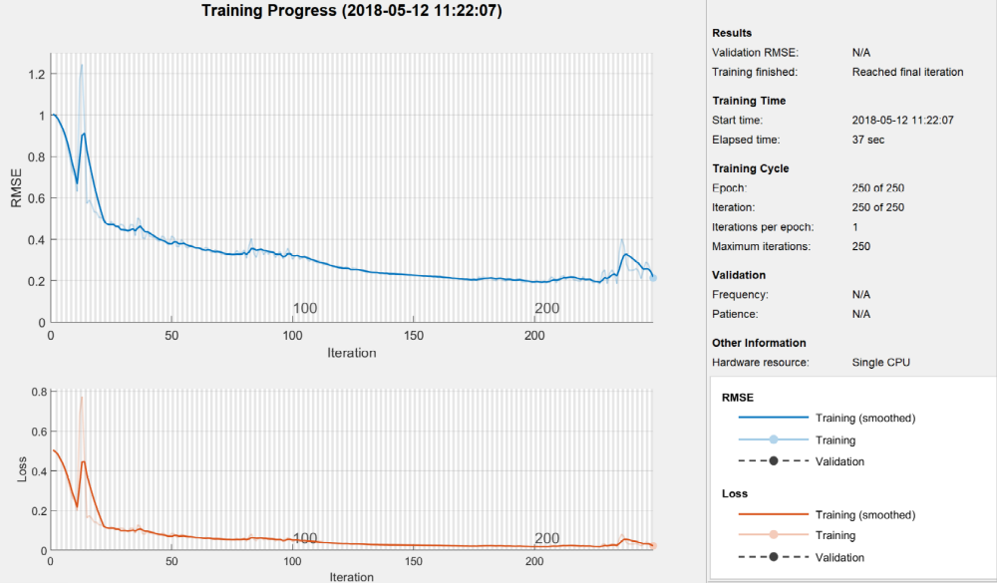

Figure 4.1 Training process of the left blind spot
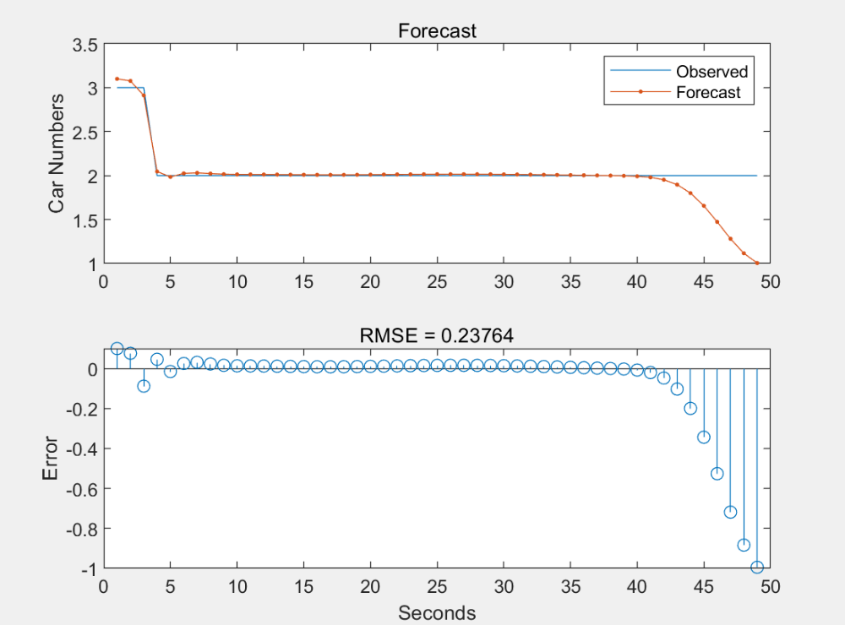
Figure 4.3 Compare the forecast sequence of the left blind spot
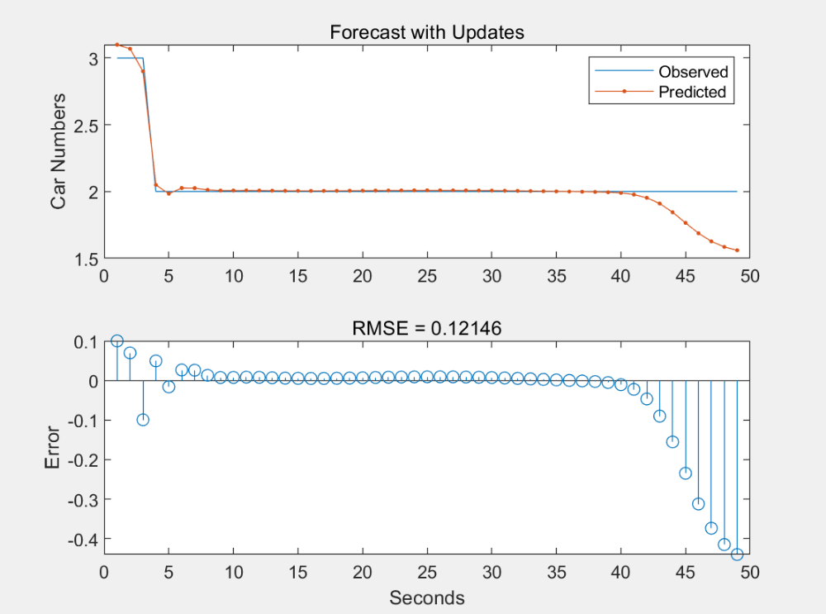
Figure 4.8 Comparison of the forecast sequence with updates of the right blind spot
- Right Blind Spot: The RMSE was significantly lower at 0.013759, indicating high accuracy in predicting the number of vehicles in this blind spot. However, after resetting the network, the RMSE increased slightly to 0.02526.

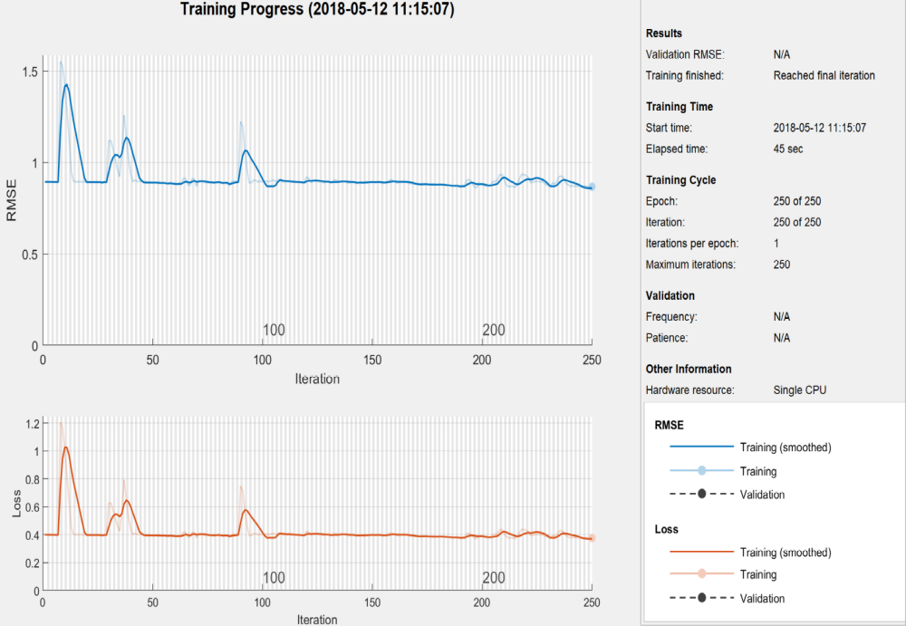

Figure 4.5 Training process of the right blind spot

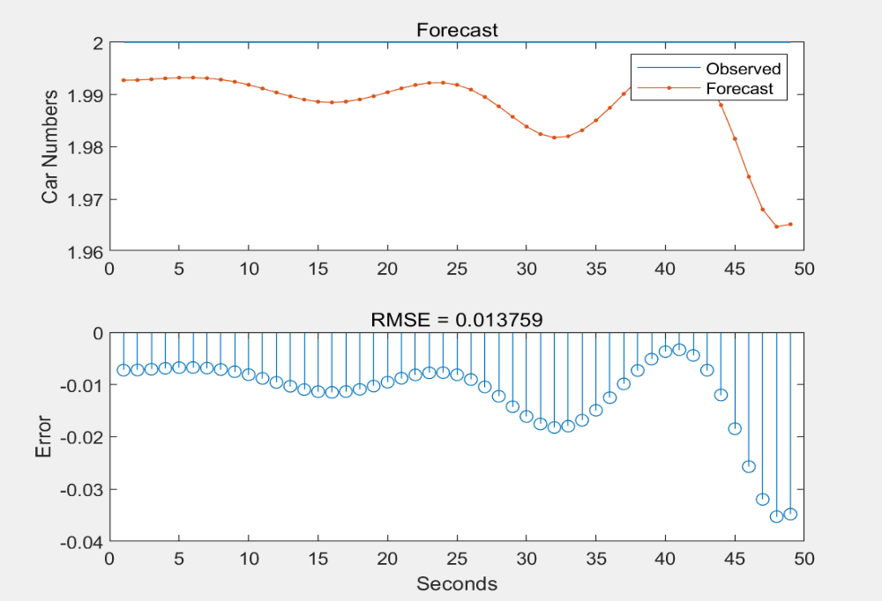
Figure 4.7 Comparison of the forecast sequence of the right blind spot

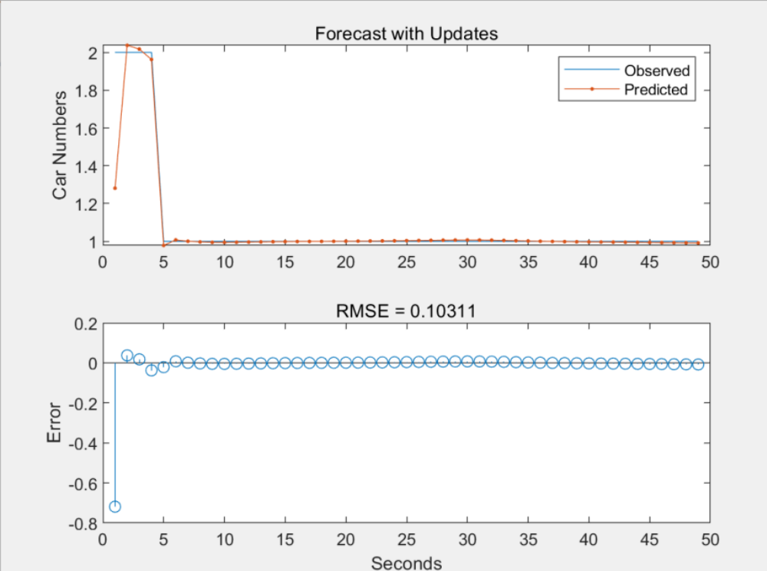
Figure 4.12 Compare the forecast sequence with updates of the front blind spot
- Front Blind Spot: The RMSE for the front blind spot reached 0.12462, with a slight reduction to 0.10331 after resetting the network state.
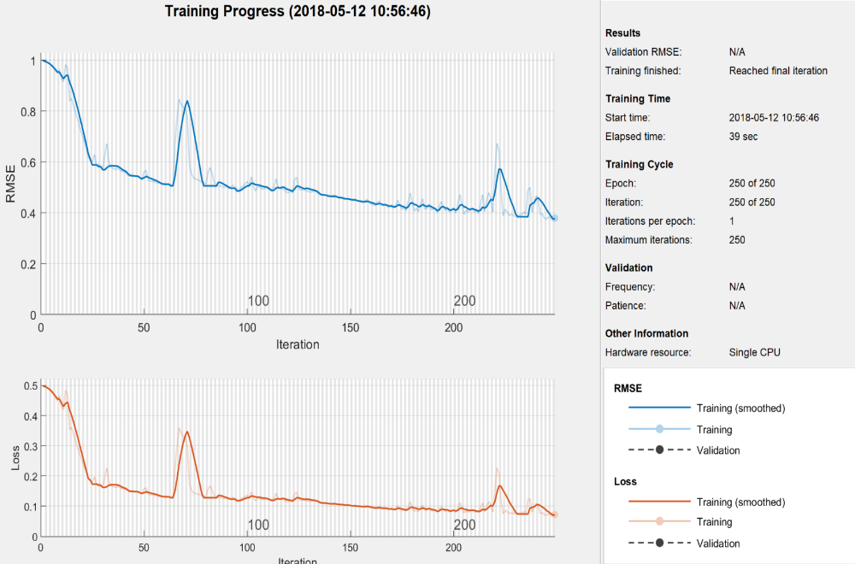
Figure 4.9 Training Process of the front blind spot

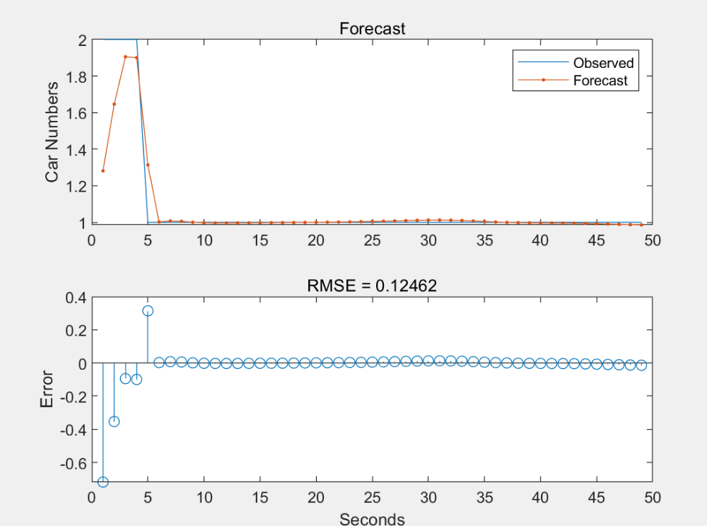
Figure 4.11 Comparisons of the forecast sequence of the front blind spot

Figure 4.12 Compare the forecast sequence with updates of the front blind spot
- Rear Blind Spot: This zone showed the highest RMSE at 0.3517, indicating more significant prediction errors. However, after network state adjustments, the RMSE dropped to 0.028362, demonstrating considerable improvement in accuracy.

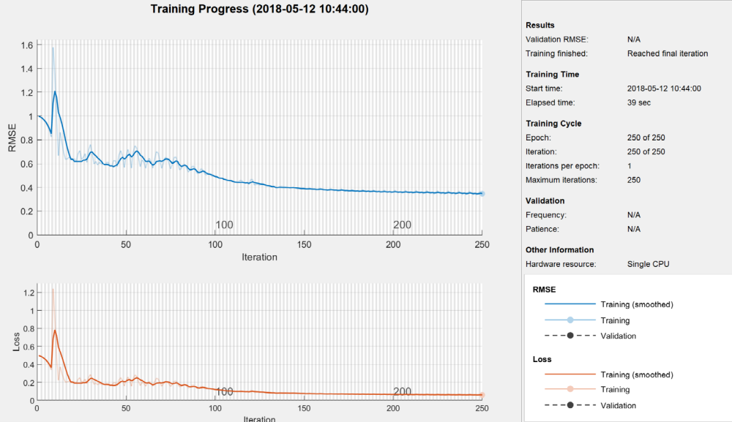
Figure 4.13 Training Process of the behind blind spot
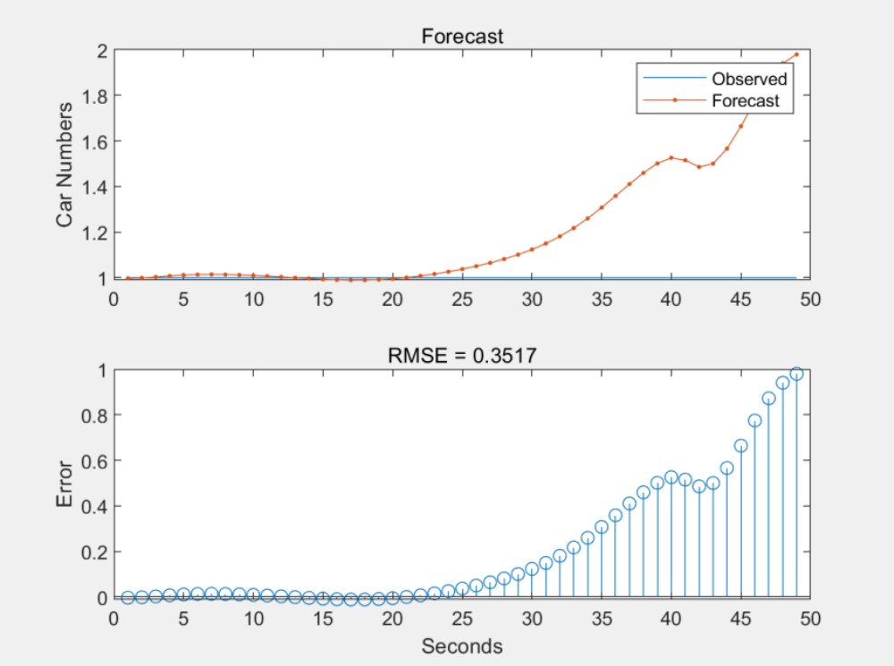
Figure 4.15 Compare the forecast sequence of the behind blind spot

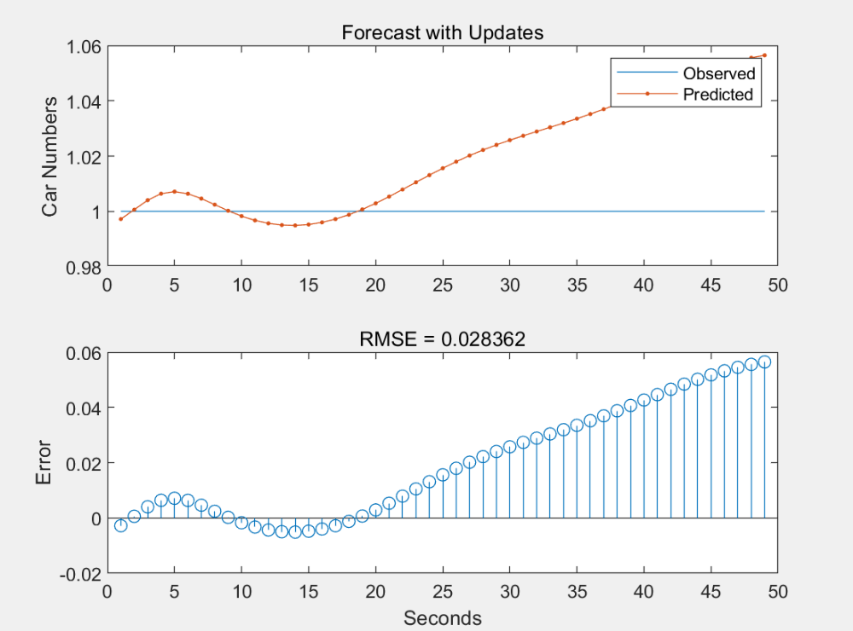
Figure 4.16 Compare the forecast sequence with updates of the behind blind spot

4.3 Limitations
Although the system demonstrated promising results, several limitations were identified:
- Histograms: While effective, histogram-based detection can struggle with reaching the maximum grayscale range, and the contrast in images may be overly stretched, resulting in data loss.
- SIFT Algorithm: The SIFT algorithm showed limitations due to its slow processing speed, which made real-time detection challenging. Moreover, feature point detection was less effective for smooth objects, reducing accuracy.
Chapter 5: Analysis and Discussions
In this chapter, the experimental results are thoroughly analyzed, and the performance of the blind spot detection system is discussed. The analysis focuses on comparing the results obtained using different algorithms and assessing the overall effectiveness of the system in detecting vehicles in blind spots. The chapter also evaluates the predictive accuracy of the Recurrent Neural Network (RNN) model and discusses areas for improvement.
5.1 Analysis
The primary goal of this project was to accurately detect vehicles in a vehicle’s blind spots using camera-based monitoring and advanced algorithms. The Hidden Markov Model (HMM) was employed to calculate the probability of accidents occurring based on the presence of cars in blind spots. The Viterbi and Baum-Welch algorithms were applied to generate state transition probabilities and predict future occurrences of accidents.
The RNN model, used for predicting the number of cars in the blind spots, showed varying accuracy across different zones. The RMSE (Root Mean Square Error) values calculated during the experiments indicated that the predictions for the right blind spot were the most accurate, with an RMSE of 0.013759, while the rear blind spot had the highest error with an RMSE of 0.3517.
The system's real-time detection capability was evaluated by comparing two approaches:
- Prediction Using Previous Sequence: The first method used previous sequences to predict the number of cars in the blind spot. This resulted in higher RMSE values for certain blind spots, particularly the rear zone.
- Resetting the Network State: By resetting the network state, the prediction accuracy improved significantly, with lower RMSE values, especially for the rear blind spot, which reduced its error from 0.3517 to 0.028362.

5.2 Discussion
The comparison of the histogram and SIFT (Scale-Invariant Feature Transform) algorithms revealed that the histogram-based method performed better for real-time detection, thanks to its faster computation speed. In contrast, the SIFT algorithm, though highly accurate in feature detection, was too slow for practical use in real-time monitoring systems. Thus, only the histogram method was used to calculate the probability of accidents, which was shown to be relatively low (below 40%).
The RNN model proved effective in predicting the number of cars in the blind spots based on past sequences, with varying degrees of accuracy depending on the specific blind spot. The results show that using a deep learning model like RNN can significantly enhance the prediction capability of blind spot warning systems. However, there is room for improvement, particularly in optimizing the system for the rear blind spot, where higher prediction errors were observed.
In conclusion, while the system performed well in detecting and predicting vehicles in blind spots, improvements can be made to enhance accuracy and reduce false positives, especially in the rear zone. The findings also suggest that integrating additional algorithms and optimizing existing ones, such as SIFT, could further improve the system's performance in the future.

Chapter 6: Conclusion and Future Work
This chapter provides a summary of the project, highlighting the methodology, results, and conclusions drawn from the research. It also discusses areas for future work, where enhancements to the blind spot detection system can be made to improve its accuracy and efficiency.

6.1 Conclusion
The primary objective of this project was to develop an efficient blind spot warning system (BSWS) using cameras and deep learning techniques to reduce traffic accidents. The system was designed to detect vehicles in the blind spots of cars by analyzing video feeds from multiple cameras and applying machine learning algorithms to predict potential hazards.
Two main algorithms were employed to detect objects in the blind spots: the histogram-based method and the SIFT algorithm. The comparison revealed that the histogram method was more suitable for real-time detection due to its fast processing speed, while SIFT, despite its higher accuracy, was too slow for practical use in the system.
The Hidden Markov Model (HMM) was used to calculate the probability of accidents occurring when vehicles were detected in the blind spots. The Viterbi and Baum-Welch algorithms were applied to obtain transition probabilities, which helped predict the likelihood of an accident based on previous data.
To predict the number of cars entering blind spots over time, a Recurrent Neural Network (RNN) was used. The system achieved high prediction accuracy in most cases, with the right blind spot having the lowest RMSE (0.013759), while the rear blind spot had the highest error (0.3517). By resetting the network state, the prediction accuracy improved significantly, especially for the rear blind spot, where the error dropped to 0.028362.
Overall, the system performed well in detecting vehicles in blind spots and predicting potential hazards, making it a valuable tool for enhancing driver safety. However, there are still limitations, particularly in the rear blind spot, that require further attention.

6.2 Future Work
Although this project made significant strides in developing a functional blind spot warning system, there are several areas where improvements can be made:
- Improving Detection Accuracy: The current system relies on a histogram-based method for real-time detection, which, while fast, may not always provide the highest accuracy. Future work should focus on exploring more advanced image processing algorithms, such as deep learning-based object detection, to improve detection accuracy while maintaining real-time performance.
- Enhancing Real-Time Performance: The SIFT algorithm, although highly accurate, was too slow for real-time detection. Future research could explore methods to accelerate SIFT or alternative algorithms that combine high accuracy with fast processing speeds. Additionally, optimizing the deep learning models, such as RNN and LSTM, to run more efficiently in real-time scenarios will be essential for system scalability.
- Expanding the Dataset: The dataset used in this project was limited to a few videos captured from four blind spot zones. Expanding the dataset to include more diverse driving conditions, different vehicle types, and various weather conditions would improve the robustness and adaptability of the system.
- Incorporating Tracking Algorithms: Adding a tracking algorithm based on video analysis could allow the system to continuously monitor moving objects in blind spots and provide more timely alerts to drivers, giving them enough time to react and prevent accidents.
- Reducing False Positives: One of the challenges observed was the occurrence of false positives, particularly in the rear blind spot. Future work should aim to refine the detection system to reduce these errors, ensuring that the alerts provided are reliable and accurate.
- Hardware Integration: To bring this system closer to real-world applications, future work should explore the integration of the detection algorithms into vehicle hardware systems, such as advanced driver-assistance systems (ADAS) or fully autonomous vehicles. This would involve working on embedded system optimization to ensure the algorithms can run efficiently on vehicle hardware.
In conclusion, while the proposed system demonstrates great potential in reducing traffic accidents by detecting vehicles in blind spots, there are still opportunities to improve its accuracy, performance, and real-world applicability through further research and development.

-------------------------------------------------

---

## Chapter 3: Methodology

This chapter introduces the research methods employed in this report, specifically focusing on the methodology for blind spot detection using histograms, SIFT (Scale-Invariant Feature Transform), and HMM (Hidden Markov Model). The details of each method will be explained clearly throughout this chapter.

### 3.1 Overview of Blind Spot Zones

The primary blind spots of a car are situated in four critical areas: the front-below zone, the rear-below zone, the left-below zone, and the right-below zone. To effectively monitor these areas, it is prudent to install four cameras, each dedicated to one blind spot. Due to the elevated position of the driver, it can be challenging to observe the surrounding environment, increasing the risk of serious accidents (Cheng et al., 2016; McCarthy & Gilbert, 1996).

- **Blind Zone 1**: Front-below zone
- **Blind Zone 2**: Rear-below zone
- **Blind Zone 3**: Left-below zone
- **Blind Zone 4**: Right-below zone

Right turns pose particular hazards, even at low speeds, as the vehicle’s turning radius can lead to collisions with other vehicles and pedestrians located in these blind spots (Zhang, Liu & Ma, 2015). Therefore, the system must detect obstacles in these zones and alert the driver promptly. The primary objectives of this report are twofold: first, to assess whether the Blind Spot Detection System (BSDS) can identify obstacles in real-time; and second, to determine if the response time is sufficient for drivers to react and avert accidents.

If any vehicles, pedestrians, or cyclists are detected in the blind spot zones, the Blind Spot Warning System (BSWS) should activate a warning for the driver.

To identify the most suitable algorithm for detection, four videos were captured from the various blind spots (front, rear, left, and right). The following steps were implemented to achieve effective detection in these zones:

1. Identify and mark the driver’s blind spot zone with a rectangle.
2. Employ various algorithms to detect the presence of cars in the blind spot zone.
3. Calculate the number of cars in the driver’s blind spots in real-time.
4. Use Hidden Markov Model (HMM) to assess the probability of potential accidents when multiple cars are present in the blind spots.
5. Predict the future number of cars in the blind spots based on experimental data.

### 3.2 Histogram-Based Detection

Image enhancement technologies are widely utilized in various fields, including traffic and medical applications (Gonzalez and Woods, 2010). Histogram transformation is a common method for image enhancement and was employed in this project. A histogram, defined as a statistical function relating greyscale levels to pixel intensity, reflects the frequency of different greyscale levels within an image (Li, Zhang & Zhang, 2014; Sonka, Hlavac & Blyle, 2003).

To detect the presence of cars in the blind spot zone, a reference image without any cars was selected, and its histogram was acquired for comparison with other images. Three methods were explored to observe the blind spot using the histogram: inner product, entropy, and HOG (Histogram of Oriented Gradients).

#### 3.2.1 Inner Product

To detect conditions in the blind spots, the inner product of two vectors is calculated. An image devoid of cars in the blind spot zone is chosen (see Figure 3.1). This image is transformed into a greyscale image to obtain its histogram, and the vector \(I_0(x_0, y_0)\) is determined. The length \(L_0\) is calculated using:

\[
L_0 = \sqrt{\sum(I_0' \cdot I_0)} \tag{3.1}
\]

Next, as video frames are read, the vector for each frame is set to \(I_i\) (where \(i\) is the frame number). Thus, the length \(L_i\) can be obtained from:

\[
L_i = \sqrt{\sum(I_i' \cdot I_i)} \tag{3.2}
\]

The inner product is calculated using:

\[
IP = \text{dot}(I_0, I_i) \tag{3.3}
\]

From the above, we can derive:

\[
\text{dot}(I_0, I_i) = L_0 \cdot L_i \cdot \cos \alpha \tag{3.4}
\]

The value of \(\cos \alpha\) can be calculated with:

\[
\cos \alpha = \frac{\text{dot}(I_0, I_i)}{L_0 \cdot L_i} \tag{3.5}
\]

If the computed value of \(\cos \alpha\) falls within a specified range \([a, b]\), it indicates the presence of cars in the blind spot zone; otherwise, it suggests that there are no vehicles present.

#### 3.2.2 Entropy

Shannon introduced the concept of information entropy, which measures the information content of a given sequence. As noted by Miśkiewicz (2016), entropy serves as a significant parameter representing system states in statistical physics and is defined using a probability distribution function (PDF) based on histograms.

After selecting a suitable histogram image (\(I_0\)) without cars, the entropy \(H_0\) of this image is calculated as:

\[
H_i = \sum P_i \log_2 P_i \tag{3.6}
\]

Here, \(P_i\) represents the probability of a specific greyscale value occurring in the image. The entropy \(H_i\) for the frames of the video is computed similarly, and \(H_0\) and \(H_i\) are compared to determine if cars are present in the driver's blind spot.

#### 3.2.3 HOG and SVM

Dalal and Triggs proposed a system in 2005 that combines the HOG algorithm with an SVM (Support Vector Machine) classifier. Although the original HOG algorithm required complex computations, making it time-consuming, researchers have since explored more efficient classifiers while maintaining accuracy and speed (Kalshaonkar & Kuwelkar, 2017).

The steps for conducting the experiment using HOG and SVM include:

1. **Positive Sample Set**: Collect positive samples and calculate the HOG feature vectors to obtain descriptors.
2. **Negative Sample Set**: Collect negative samples, using images without detection targets to calculate their HOG feature vectors.
3. **SVM Training**: Train the SVM on both positive and negative samples to obtain individual models.
4. **Hard-Negative Mining**: Use the trained model to detect negative samples at different scales. Images without targets are added to the negative sample set.
5. **Model Refinement**: Incorporate hard-negative samples and retrain the model.
6. **Final Detection**: Utilize the final classifier model to scan the test set images at various scales, extracting descriptors and classifying them. If a target is detected, it is marked accordingly. Non-maximum suppression (NMS) is applied to eliminate overlapping detections.

### 3.3 Scale-Invariant Feature Transform (SIFT)

SIFT, developed by David Lowe in 2004, is an algorithm designed to detect and describe local features in images. It identifies extreme points across various spatial scales and extracts their position, dimensions, and rotational invariance, making it suitable for object recognition and image matching (Youying & Tadahiro, 2018).

#### 3.3.1 Features of SIFT

Key features of SIFT include:

1. **Invariance**: SIFT can maintain invariance to rotation, scaling, brightness changes, and provide stability against variations in viewing angles, noise, and transformations.
2. **Detail Distinction**: The algorithm effectively distinguishes intricate details within large datasets, facilitating fast and accurate computations across massive databases.
3. **Expandability**: SIFT can be conveniently integrated with other types of feature vectors.
4. **Robustness**: A single object can produce multiple SIFT feature vectors, enhancing the algorithm's efficacy.

#### 3.3.2 Applications of SIFT

SIFT addresses various challenges in image registration and object tracking, including:

1. Rotation, scaling, and translation (RST) of the target.
2. Affine transformations and changes in viewpoint.
3. Effects of illumination.
4. Target occlusion.
5. Clutter and noise.

#### 3.3.3 Main Steps of SIFT

The SIFT algorithm focuses on identifying corners across different spatial scales. The key points detected by SIFT are robust against various conditions, such as illumination and noise. Lowe (2004) outlined the SIFT process in four primary steps, which account for 99.8% of the total computation time:

1. **Scale-Space Extremum Detection**: Identify potential interest points across scales using a Gaussian differentiation function. Construct a Gaussian pyramid with blurred images at different scales and detect extreme points by comparing intensity values with neighboring pixels.
2. **Key Point Location**: Determine the scale and position of each candidate point using a best-fit model, achieving sub-pixel accuracy through the application of ternary quadratic functions.
3. **Orientation Assignment**: Assign an orientation to each key point based on local image gradient directions to ensure invariance to rotation.
4. **Key Point Descriptor**: Generate a descriptor for each key point, representing the local gradient information, allowing for robust matching against other images.

By utilizing these methodologies, the project aims to effectively detect obstacles in blind spot zones,

contributing to enhanced vehicle safety and reduced accident rates.

### 3.4 Hidden Markov Model (HMM)

A Hidden Markov Model (HMM) is a statistical model where the system is assumed to be a Markov process with hidden states. In this project, HMM is utilized to analyze the detected vehicles' movement within the blind spot zones over time. The essential components of HMM include:

1. **States**: Represent different configurations or conditions of the system (e.g., the presence of vehicles in blind spots).
2. **Observations**: Indicate the observable events that provide information about the hidden states (e.g., detections of vehicles).
3. **Transition Probabilities**: Define the likelihood of transitioning from one state to another over time.
4. **Emission Probabilities**: Determine the likelihood of observing a particular output from a given state.

### 3.5 Experimental Setup

To validate the methodology, a dataset comprising video footage captured from the blind spot zones of vehicles was compiled. The following parameters were established:

1. **Camera Specifications**: Each camera was calibrated to ensure optimal detection capabilities.
2. **Data Collection**: Videos were recorded under various conditions (day/night, weather variations) to assess the robustness of the detection methods.
3. **Testing Environment**: Experiments were conducted in a controlled environment with known vehicle patterns and trajectories to evaluate detection accuracy.

The experimental results will be analyzed to assess the performance of each detection method in identifying obstacles in the blind spot zones and their potential implications for enhancing vehicle safety systems.

---

This revised methodology provides a clear and structured approach

